|  |  |  |  |  |
| --- | --- | --- | --- | --- |
|  |  | | |  |
|  |  | | |  |
|  | Auto Tow/Haul | | |  |
|  | (F002992/A) | | |  |
|  |  | | |  |
|  |  | | |  |
| Document Type | **Aggregated Feature Specification** | | |  |
| Template Version | **6.0c** | | |  |
| Document ID | **document1** | | |  |
| Document Location |  | | |  |
| Document Owner | **Celso Dantas (csantosj)** | | |  |
| Document Revision | **C** | | |  |
| Document Status | **Finalized** | | |  |
| Date Issued | **2020-01-27** | | |  |
| Date Revised | **2021-05-24** | | |  |
| Document Classification | GIS1 Item Number: | **27.60/35** | |  |
| GIS2 Classification: | **Confidential** | |
|  | | | | |
|  | | | | |
| Document Approval | | | | |
| Person | Role | | Email Confirmation | Date |
|  |  | |  |  |
|  |  | |  |  |

Printed Copies Are Uncontrolled

# Disclaimer

**This document contains Ford Motor Company Confidential information. Disclosure of the information contained in any portion of this document is not permitted without the expressed, written consent of a duly authorized representative of Ford Motor Company, Dearborn, Michigan, U.S.A.**

**Copyright, Ó 2016 Ford Motor Company**

This document contains information developed and accumulated by and for FORD MOTOR COMPANY. As such, it is a proprietary document, which, if disseminated to unauthorized persons, would provide others with restricted information, data, or procedures not otherwise available, exposing the FORD MOTOR COMPANY to potential harm.

Employees and suppliers having custody of this specification or authorized to use it must be cognizant of its proprietary nature and ensure that the information herein is not made available to unauthorized persons.

FORD MOTOR COMPANY reserves the right to protect this work as an unpublished copyrighted work in the event of an inadvertent or deliberate unauthorized publication. FORD MOTOR COMPANY also reserves its rights under copyright laws to protect this work as a published work.

This document or portions thereof shall not be distributed outside FORD MOTOR COMPANY without prior written consent. Refer all questions concerning disclosure to the author(s) or to any duly authorized representative of Ford Motor Company.

# Contents

Disclaimer 2

Contents 3

1 INTRODUCTION 7

1.1 Document Purpose 7

1.2 Document Scope 7

1.3 Document Audience 7

1.3.1 Stakeholder List 7

1.4 Document Organization 8

1.4.1 Document Context 8

1.4.2 Document Structure 8

1.5 Document Conventions 8

1.5.1 Requirements Templates 8

1.5.1.1 Identification of requirements 8

1.5.1.2 Requirements Attributes 8

2 Feature DOCUMENT 9

2.1 Feature Overview 9

2.1.1 Feature Purpose and Description 9

2.1.2 Feature Variants 9

2.1.3 Regions & Markets 9

2.1.4 Input Requirements 9

2.1.4.1 Legal Requirements 9

2.1.4.2 Trustmark Requirements 9

2.1.4.3 Industry Standards 9

2.1.5 Lessons Learned 9

2.1.6 Assumptions 10

2.1.7 References 10

2.1.7.1 Ford documents 10

2.1.7.2 External documents and publications 10

2.1.8 Glossary 10

2.1.8.1 Definitions 10

2.1.8.2 Abbreviations 10

2.1.8.3 Parameters / Values 11

2.2 Feature Context 11

2.2.1 Feature Context Diagram 11

2.2.2 List of Influences 12

2.3 Feature Modeling 13

2.3.1 Operation Modes and States 13

2.3.2 Use Cases 14

2.3.2.1 Use Case Diagram 14

2.3.2.2 Actors 14

2.3.2.3 Use Case Descriptions 15

2.3.3 Driving Scenarios 15

2.3.4 Decision Tables 15

2.4 Feature Requirements 15

2.4.1 Functional Requirements 15

2.4.1.1 Error Handling 15

2.4.2 Nonfunctional Requirements 15

2.4.2.1 Security 15

2.4.2.2 Reliability 15

2.4.3 HMI Requirements 15

2.4.4 Other Requirements 16

2.4.4.1 Manufacturing Requirements 16

2.4.4.2 Service Requirements 16

2.4.4.3 After Sales Requirements 16

2.4.4.4 Process requirements 16

2.5 Functional Safety 16

2.5.1 System Behaviors for HARA 16

2.5.2 Safety Assumptions 16

2.5.3 Safety Goals 17

2.5.4 Functional Safety Requirements 17

2.5.4.1 <Goal 1 Name> 17

2.5.4.2 <Goal 2 Name> 17

2.5.4.3 Derivation of Requirements on Assumptions 17

2.5.5 (Decomposed) Functional Safety Requirements 17

2.6 Functional Architecture 18

3 FUNCTIONAL ARCHITECTURE 19

3.1 Description 19

3.2 Function List 19

3.3 Signal List 20

4 FUNCTION SPECIFICATIONS 21

4.1 Logical Function “MyLogicalFunction1” 21

4.1.1 Function Overview 21

4.1.1.1 Description 21

4.1.1.2 Variants 21

4.1.1.3 Input Requirements 21

4.1.1.4 Assumptions 21

4.1.1.5 References 21

4.1.1.6 Glossary 21

4.1.2 Function Scope 22

4.1.3 Function Interfaces 22

4.1.3.1 Logical Inputs 22

4.1.3.2 Logical Outputs 22

4.1.3.3 Logical Parameters 23

4.1.4 Function Modeling 23

4.1.4.1 Use Cases 23

4.1.4.2 State Charts / Activity Diagrams / Sequence Diagrams / Decision Tables 23

4.1.5 Function Requirements 25

4.1.5.1 Functional Requirements 25

4.1.5.1.1 Normal Operation 25

4.1.5.1.2 Error Handling 25

4.1.5.2 Non-Functional Requirements 25

4.1.5.3 (Decomposed) Functional Safety Requirements 26

4.1.5.4 Other Requirements 26

4.1.5.4.1 Design Requirements 26

4.2 HMI Function “MyHMIFunction1” 26

4.2.1 Function Overview 27

4.2.1.1 Description 27

4.2.1.2 Variants 27

4.2.1.3 Input Requirements 27

4.2.1.4 Assumptions 27

4.2.1.5 References 27

4.2.1.6 Glossary 27

4.2.2 Function Scope 27

4.2.3 Function Interfaces 28

4.2.3.1 Logical Inputs 28

4.2.3.2 Logical Outputs 28

4.2.3.3 Logical Parameters 29

4.2.4 Function Modeling 29

4.2.4.1 Use Case(s) 29

4.2.4.2 State Charts / Activity Diagrams / Sequence Diagrams / Decision Tables 29

4.2.5 Function Requirements 29

4.2.5.1 Functional Requirements 29

4.2.5.2 Non-Functional Requirements 29

4.2.5.3 (Decomposed) Functional Safety Requirements 30

5 Feature IMPLEMENTATION SPECIFICATION 31

5.1 Feature Implementation Overview 31

5.1.1 Description 31

5.1.2 Input Requirements 31

5.1.3 Assumptions 31

5.1.4 References 32

5.1.5 Glossary 32

5.2 Functional Architecture 32

5.3 Physical Architecture 32

5.3.1 E/E Architecture 32

5.3.1.1 E/E Architecture Variants 32

5.3.1.1.1 E/E Architecture “Architecture Variant 1” 33

5.3.1.1.2 E/E Architecture “Architecture Variant 2” 34

5.3.1.2 E/E Components 34

5.3.1.3 E/E Connections 35

5.3.1.4 Signal List 35

5.3.2 Software Component Architecture 35

5.3.2.1 Description 35

5.4 Function Deployment 36

5.4.1 Deployment Variants 36

5.4.1.1 Deployment “Variant 1” 36

5.4.2 Function Allocation 37

5.4.2.1 Functional Safety 37

5.5 Feature Implementation Modeling 38

5.5.1 Component Interaction Diagrams 38

5.5.1.1 Scenario: “System Startup / Shutdown” 39

5.5.1.2 Scenario: “Normal Operation” 39

5.5.1.3 Functional Safety 39

5.5.1.3.1 Requirements Derivation Diagram 40

5.5.2 Component Interface Behavior Diagrams 40

5.6 Requirements 40

5.6.1 Requirements on Components 40

5.6.1.1 Component “MyComponent1” 40

5.6.1.2 Implemented Function “MyLogicalFunctionA_Component1” 40

5.6.1.3 Implemented Function “MyLogicalFunctionB_Component1” 43

5.6.1.4 Component “MyComponent2” 43

5.6.2 Requirements on Connections 43

5.6.2.1 CAN Bus x 43

5.6.2.1.1 Protocol Requirements 44

5.6.2.1.2 Electrical Requirements 44

5.6.2.2 MS-CAN 44

5.6.2.3 LIN x 44

5.6.2.3.1 Protocol Requirements 44

5.6.2.3.2 Electrical Requirements 44

5.6.2.4 Ethernet 44

5.6.2.5 WLAN (IEEE 802.11.x) 44

5.6.2.6 RF 44

5.6.2.7 Hardwired I/Os 44

5.6.3 Requirements on Development Process 44

6 OPEN CONCERNS 45

7 REVISION HISTORY 46

8 APPENDIX 47

8.1 Data Dictionary 47

8.1.1 Logical Signals 47

8.1.2 Logical Parameters 47

8.1.3 Technical Signals 47

8.1.3.1 GSDB Signals 47

8.1.3.2 Service Oriented Communication 47

8.1.3.3 Hardwired Signals 47

8.1.3.4 Diagnostic Interfaces 47

8.1.3.4.1 DTCs 47

8.1.3.4.2 DIDs 48

8.1.4 Technical Parameters 48

8.1.5 Mappings 48

8.1.6 Technical Interfaces 49

8.1.6.1 AIS Interfaces 49

8.1.6.1.1 Publisher Interfaces 49

8.1.6.1.2 Subscriber Interfaces 49

8.1.6.2 Service Oriented CoATHuncation (SoC) Interfaces 50

8.1.6.3 AUTOSAR Ports (SW Interfaces) 50

8.1.7 Messages 50

8.1.7.1 CAN Bus “<Bus Name>” 50

8.1.7.2 LIN Bus “<Bus Name>” 50

8.1.8 Encoding Types 51

**List of Figures**

Figure 1: Context Diagram 12

Figure 2: Feature Operation States and Modes 13

Figure 3: Use Case Diagram 14

Figure 4: Functional Architecture 19

Figure 5: Context Diagram of Function MyLogicalFunction 22

Figure 6: State Machine of Function “MyLogicalFunction1” 24

Figure 7: Activity Diagram of Function “MyLogicalFunction1” 24

Figure 8: Sequence Diagram of Function “MyLogicalFunction1” 25

Figure 9: Context Diagram of HMI Function 1 28

Figure 10: “E/E Architecture Variant 1” 33

Figure 11: “E/E Architecture Variant 1” 34

Figure 12: AUTOSAR compliant SW Component Architecture 36

Figure 13: Sequence Chart "Normal Operation" 39

**List of Tables**

Table 1: Feature Variants 9

Table 2: Ford Documents 10

Table 3: External documents and publications 10

Table 4: Definitions used in this document 10

Table 5: Abbreviations used in this document. 11

Table 6: Parameters / Values used in this document 11

Table 7: List of Influences 12

Table 8: Operation Modes 13

Table 9: Transition between Operational States 14

Table 10: List of Actors 15

Table 11: System Behaviors for HARA 16

Table 12: Functional Safety Assumptions 17

Table 13: Functional Safety Goals 17

Table 14: Requirements Decomposition Table 18

Table 15: List of Logical Functions 20

Table 16: Decision Table of Function “MyLogicalFunction1” 25

Table 17: Electrical Components 35

Table 18: E/E Connections 35

Table 19: Function Allocation Table 37

Table 20: Function Allocation Table 38

Table 21: Architectural Redundancy SuATHary 38

Table 22: Fault Handling Time Table 40

Table 23: Input Signal mappings of Function “MyLogicalFunctionA_Component1” 41

Table 24: Output Signal mappings of Function “MyLogicalFunctionA_Component1”A 42

Table 25: Parameter mappings of Function “MyLogicalFunctionA_Component1” 42

Table 26: Component Specific Requirements 43

Table 27: Requirements Inherited From Logical Function 43

Table 28: Open Concerns 45

# INTRODUCTION

## Document Purpose

The Aggregated Feature Specification (AFS) specifies a Feature from Feature level (customer & market perspective) down to Component level on an electrical platform.

The 3 chapters

* Feature Document
* Function Specifications
* Feature Implementation Specification

correspond to the 3 levels of the RE Information Model - Feature Level, Function Level, and Component Level (cross-ECU/platform view only). The AFS requirements are cascaded to the ECU Functional Specs on Component Level.

## Document Scope

The following from the [Global Feature & Function List](https://www.vsemweb.ford.com:443/tc/launchapp?-attach=true&-s=226TCSession&-o=ZmZNi0JHx3NrTDAAAAAAAAAAAAA) and its deployment to the electrical architecture is described in this :

* FNV2

## Document Audience

The is authored by Mahender Kotha / Feature Owner. All Stakeholders, i.e., all people who have a valid interest in the ECU behavior should read and, if possible, review the . It needs to be guaranteed, that all stakeholders have access to the currently valid version of the .

### Stakeholder List

For the latest list of the stakeholders and their roles & responsibilities refer to <Put VSEM Link here>.

|  |  |  |
| --- | --- | --- |
| **Name** | **CDSID** | **Role** |
| Kotha, Mahender (M.) | mkotha | Feature owner – Distributed Features |
| Esler, Craig (C.E.) | cesler | Feature Owner, LIGHTING, LOCKING, & ASSO |
| Hwang, Steve (S). | shwang7 | D&R– SUSPENSION APPS BOF & UNI (VDM module) |
| Diakiw, Markian (M.O.) | mdiakiw1 | Technical Expert - PVCRM, TRANSMISSION ELECTRONICS |
| Schmitt, David (D.H.) | dschmit6 | TE Vehicle Controls, PT CONTROLS DIESEL & GAS |
| Myslinski, Jason (J.S.) | jmyslin2 | Infotainment System Eng, INFOTAIN&CONNECT ELECTR/A |
| Ahmed Awadi | aawadi1 | Supervisor – distributed features |
| Aleid, Ehab (E.) | EALEID | EPS Feature Engineer, LIGHTING, LOCKING, & ASSO |
| Avila, Mijail (M.) | mavila | Software Engineer, ELECTRICAL MODULES MEX |
| Bledi Uzuni | buzuni | SBW Calibration Lead - A/T Shifters and coolers |
| Watkins, Scott (S.) | swatkins | DI Technical Expert, ELECTRICAL MODULES |
| Garza, Veronica (V.) | vgarza5 | Core Engineer, ELECTRICAL MODULES MEX |

**#Hint:** Refer to [Ford RE Wiki – Stakeholder List](http://wiki.ford.com/display/RequirementsEngineering/Stakeholder+Analysis) on how to create a stakeholder list. The stakeholder list should be stored in VSEM in the pseudo folder “General Data Artifacts” of the corresponding feature / function / component.

## Document Organization

### Document Context

Refer to the [Ford RE Wiki](http://wiki.ford.com/display/RequirementsEngineering/Requirements+Engineering+for+SW+Enabled+Features) to get more information about the different Requirements Engineering (RE) templates (and how the relates to those) and the overall RE approach for SW-enabled Features.

### Document Structure

The structure of this document is explained below:

**Section 1** – Introduction how to use this document including responsibilities and requisite documents. Explains the terminology. Gives a clarification of the definitions, concepts and abbreviations used in the document.

**Section 2** – Document. Defines the Feature level requirements of the realized by the system described in this specification

**Section 3** – Functional Architecture: Specifies the functional decomposition of the .

**Section 4** – Function Specifications: Specifies the Logical Functions of the functional architecture of the .

**Section 5** – Implementation Specification: Specifies details of how the / Logical Functions are deployed to the given electrical platform.

**Section 6** – List Open Concerns

**Section 7** Revision History.

**Section 8** – Appendix (Data Dictionary, etc.)

## Document Conventions

### Requirements Templates

Each requirement, use case or scenario in this specification shall follow the corresponding template given in the document template *Specification_Macros.dotm* at [RE Wiki - Specification Templates](http://wiki.ford.com/display/RequirementsEngineering/Specification+templates?src=contextnavpagetreemode).

#### Identification of requirements

The unique requirement ID given in the headline of any requirement follows the requirement throughout the development process. The requirement ID format follows a well-defined syntax.

All identifiers in this specification shall be composed of 4 parts:

* A leading prefix, which indicates the type of requirement (R=Requirement, UC=Use Case, SC=Scenario, …)
* A prefix, which indicates the abstraction level (F=Feature, FNC=Function, CMP = component).
* Followed by a name, indicating the scope, which the requirement belongs to (e.g. feature or function name)
* Ending with the actual requirement number

*Example:*

*R_CMP_LockArbitrator_00004* This is the fourth requirement on component level for the function Lock Arbitrator.

#### Requirements Attributes

The templates provided by *Specification_Macros.dotm* define a list of attributes for each requirement. This helps to classify the requirement. The attributes are explained at [RE Wiki - Requirements Attributes](http://wiki.ford.com/display/RequirementsEngineering/Requirements+Attributes?src=contextnavpagetreemode).

# Feature DOCUMENT

## Overview

### Feature Purpose and Description

The purpose of Auto Tow/Haul mode is to automatically detect that the vehicle is towing a heavy trailer and adjust the powertrain, Chassis and Active Noise Cancelation (ANC) / Engine Sound Enhancement (ESE) settings

PCM/TCM detects load on the powertrain above a predetermined threshold, and it sends a signal to SDM Module and cluster (Telltale) to indicate Tow Haul is active. SDM module sends signal to the rest of the affected modules indicating that Tow/Haul is engaged.

Each module will activate the appropriate settings associated with Tow/Haul mode.

When ignition is RUN, the driver can view their saved Auto Tow Haul settings on the APIM with a press from the menu section. Lastly the driver can save the current settings Auto Tow Haul available on their vehicle by pressing the automatic or Off soft buttons from the menu.

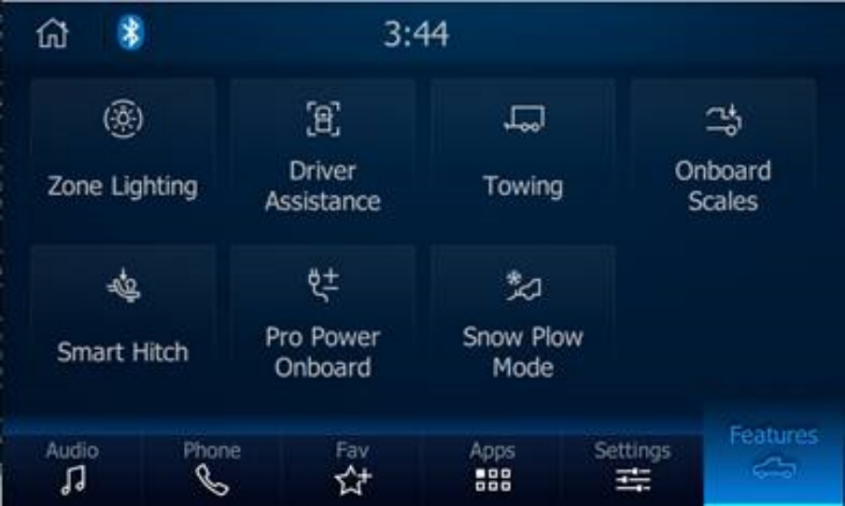 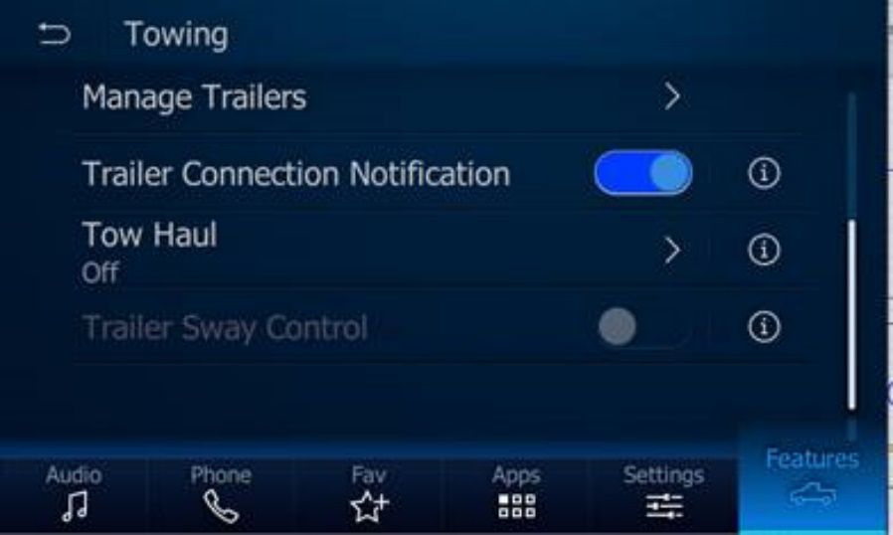

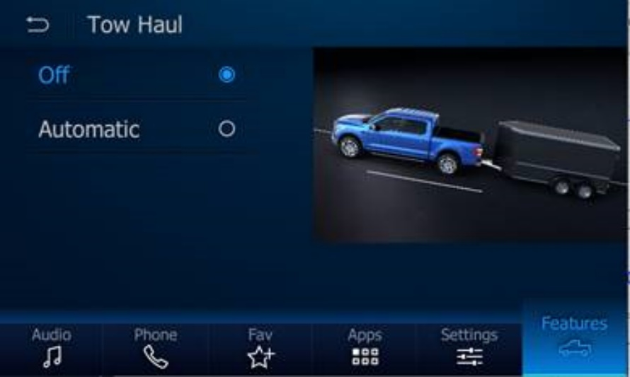

### Auto Tow Active Status Determination

Auto Tow-Haul Feature shall arbitrate the feature activation menu and the trailer detection algorithms.

The drive mode specific handling shall be arbitrated by the SDM Main Software.

The feature shall detect the trailer in all drive modes. There shall be a logic implemented by the Auto Tow-Haul Feature, such as activation per ignition cycle, in order to prevent switching of the Auto Tow Active Status and associated Drive Mode performance, which would be undesirable to the driver.

The signal Auto Tow Active Status shall be set to True if

a) Auto Tow-Haul Feature is set via HMI settings as “Auto” and a trailer is detected.

It shall be false in all other cases.

### Auto Tow Haul Mode

Auto Tow-Haul Feature shall utilize various algorithms and sensing technologies to automatically select the most appropriate drive mode according to the trailer towing condition.

### Auto Tow Active Status Signal

The Auto Tow Active Status signal shall communicate whether SDM shall adapt the vehicle behavior to an automatically detected trailer.

The SDM CAN signal „ Auto Tow Active Status” shall have the following signal properties:

|  |  |  |  |  |
| --- | --- | --- | --- | --- |
| **Name** | **Description** | **Transmitter** | **Receiver** | **Sampling Interval (ms)** |
| AutoTowActv_B_Stat | Auto Tow-Haul mode status. Used to enable Auto Tow-Haul mode in ATH Feature. | PCM, ECM | ABS | 1000 E/P |

The Auto Tow Active Status signal shall communicate the status of the Auto Tow Active Status via the following encoding:

|  |  |  |
| --- | --- | --- |
| State | Encoding | Description |
| 0x0 | No | No trailer, Auto Tow interaction are inactive |
| 0x1 | Yes | Trailer detected, Auto Tow interaction are applied according to drive mode calibration |

### Auto Tow Active Status Signal Start-Up Behavior

The Auto Tow Active Status Signal shall be set to 0x0 at start-up and each new ignition cycle.

### Feature Variants

|  |  |  |
| --- | --- | --- |
| Variant Name | Variant Description | Remarks |
| **Auto Tow Haul Mode Sync Variant** | For this variant the driver uses soft button to perform all the ATH feature functionality such as configuring ATH, saving settings, and viewing saved settings information | In production available only for Lincoln programs (U554/U611) |
| **Auto Tow Haul Mode IPC Variant** |  |  |

Table 1: Feature Variants

### Regions & Markets

|  |  |  |  |  |  |  |
| --- | --- | --- | --- | --- | --- | --- |
| **Market /**  **Region**  Variant Name | **North America** | **South America** | **Europe** | **Middle East/Africa** | **Asia / Pacific** | **China** |
| **Auto Tow Haul** | Mandatory | N/A | N/A | Mandatory | N/A | Mandatory |

Table 2: Regions & Market

### Assumptions

Assumptions:

* Vehicle is equipped with required interfaces
  + Soft button for the ATH-functions
  + Trailer connector
* SDM Feature available on vehicle
* PCM available on Vehicle

### References

#### Ford documents

List here all Ford internal documents, which are directly related to the feature.

|  |  |  |  |
| --- | --- | --- | --- |
| **Reference** | **Doc. ID** | **Title** | **Revision** |
|  | 665430– A | SDM Gen 4 - 159161_J_001_v 4.0 |  |
|  |  |  |  |

Table 3: Ford Documents

#### Definitions

|  |  |
| --- | --- |
| Definition | Description |
| ATH mode | A custom drive mode that the driver can save and return to using the ATH soft button |
| Selectable Drive Mode | A predefined set of vehicle modes the driver can select that has a default configuration for each mode |
| AWD | All Wheel Drive |

Table 4: Definitions used in this document

#### Abbreviations

|  |  |  |
| --- | --- | --- |
| Abbr. | Stands for | Description |
| AFS | Aggregated Feature Spec | Type of this document |
| SDM | Selectable Drive Mode | External Feature which allows the driver to select a predefined drive mode with default attributes using a drive mode switch |
| ECG | Enhanced Central Gateway | Module that passes messages from one vehicle network to others and hosts ATHMode main arbitration logic |
| PCM | Powertrain Control Module | Module that controls powertrain functions |
| TCCM | Transfer Case Control Module | Module that controls AWD functions |
| SDM | Selectable Drive Mode | Selectable Drive Mode feature which is a Ford in house SW hosted on the ABS module |
| EPS | Electric Powered Steering |  |
| S/S | Stop / Start | Stop / Start is a feature that automatically shuts off and starts vehicle engine |
| VDM | Vehicle Dynamics Module | Module that controls suspension functions |
| IPC | Instrument Panel Cluster | Instrument Cluster that displays information to driver |
| EOL | End of Line |  |
| Spec | Specification |  |
| CAN | Controller Area Network | Multiplexed messaging that modules use to communicate |
| FD1 | FD1 CAN Network |  |
| HS1 | High Speed 1 CAN Network |  |
| HS2 | High Speed 2 CAN Network |  |

Table 5: Abbreviations used in this document.

#### Parameters / Values

| **Name** | **Description** | **Range / Resolution** |
| --- | --- | --- |
|  |  |  |
|  |  |  |
|  |  |  |

Table 6: Parameters / Values used in this document

## Feature Context

### Feature Context Diagram

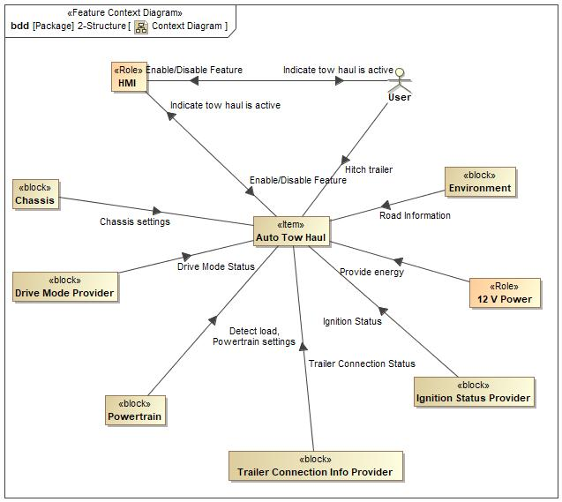

**Figure 1: Feature Context Diagram**

## List of Influences

|  |  |  |
| --- | --- | --- |
| **ID** | **External Entity** | **Influence Description** |
| Chassis settings | Chassis to Auto Tow Haul | Customer must select either “Automatic” or “Off” from the Towing settings in HMI for Chassis to engage Auto Tow Haul. |
| Detect load | Powertrain to Auto Tow Haul | Mass estimation by Powertrain is above the threshold, PT will engage Auto Tow Haul, if the customer selects “Automatic” in Towing settings.  The Auto Tow Active Status signal shall communicate whether SDM shall adapt the vehicle behavior to an automatically detected trailer. |
| Drive Mode Status | Drive Mode Provider to Auto Tow Haul | PCM Shall communicate the active drive mode IPC |
| Enable/Disable Feature | HMI to Auto Tow Haul | There shall be Auto Tow Haul adaptation when Auto Tow-Haul is deactivated (Off) or Activated (automatic) by the driver in HMI settings. |
| User to HMI | User can choose to Deactivate (Off) or Activate (Automatic) by the HMI |
| Hitch trailer | User to Auto Tow Haul | The user shall connect the trailer to the vehicle for the Auto Tow Haul to get activated. |
| Ignition Status | Ignition Status Provider to Auto Tow Haul | BCM shall provide the Ignition status for the ECG module to activate or deactivate the feature |
| Indicate tow haul is active | Auto Tow Haul to HMI | The signal “Active Drive Mode” shall communicate the active drive mode (which is e.g. used to show the active drive mode to the driver via telltales). |
| HMI to User | HMI gives the ability to turn the feature Off or Automatic |
| Powertrain settings | Powertrain to Auto Tow Haul | The PT shall inform the load status and drive mode status to the SDM for Auto Tow Haul to activate or deactivate. |
| Provide energy | 12 V Power to Auto Tow Haul | 12V Battery will provide enough power for the functionality of the feature |
| Road Information | Environment to Auto Tow Haul | Snow, Rain, slippery and terrain condition will effect the feature functionality. |
| Trailer Connection Status | Trailer Connection Info Provider to Auto Tow Haul | ITRM module will inform the Brake and light status of the trailer to the PT for Trailer connection status. |

**Table 7: List of Influence**

## Feature Modeling

## Operation Modes and States

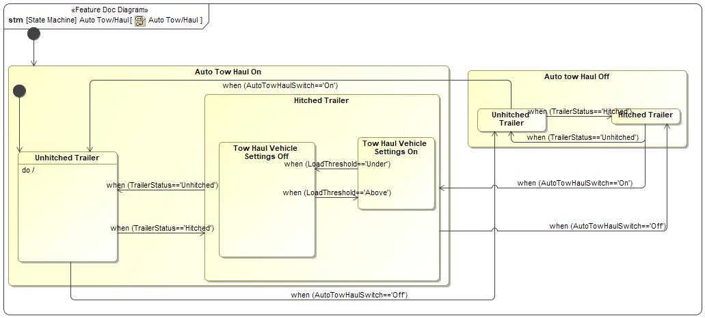

Figure 2: Operation Modes and States

|  |  |  |
| --- | --- | --- |
| **State** | **Description** | **Requirements Reference** (optional) |
| Auto tow Haul Off | There shall not be Auto Tow Haul adaptation when Auto Tow-Haul is deactivated (Off) by the driver in HMI settings. |  |
| Auto Tow Haul On | There shall be Auto Tow Haul adaptation when Auto Tow-Haul is activated (Automatic) by the driver in HMI settings. |  |
| Hitched Trailer | Trailer detected, Auto Tow interaction are applied according to drive mode calibration |  |
| Unhitched Trailer | Trailer undetected, Auto Tow interaction are applied according to drive mode calibration |  |

Table 8: Operation Modes and States on Auto Tow/Haul

### Use Cases

#### Use Case Diagram 1572439108.jpg

Figure 3: Use Case Diagram

#### Actors

| **Actor** | **Description** |
| --- | --- |
| Chassis | Suspension, Steering settings are controlled by Chassis module |
| Diagnostic Tool | The diagnostic tool will enable/disable the feature |
| Drive Mode Provider | The driver is the user of the feature |
| HMI | HMI gives the ability to control the feature settings |
| User | User can turn the feature Off or Automatic |

**Table 9: Actors**

#### Use Case Descriptions

ATH Configuration

|  |  |  |
| --- | --- | --- |
| **Purpose** |  | ATH feature configuration |
| **Actors** |  | Diagnostic Tool |
| **Precondition** |  | * ATH software on vehicle * Diagnostic tool connected to vehicle |
|  |  |  |
| **Main Flow** | M1 | Tool sets the ATH DID configurations that enable/disables the ATH feature and ATH-functions available on vehicle |
|  |  |  |
| **Alternative Flow 1** |  |  |

**Table 10: ATH Configuration**

Display ATH Saved Settings

|  |  |  |
| --- | --- | --- |
| **Purpose** |  | Show ATH saved settings on APIM via Towing menu |
| **Actors** |  | Driver |
| **Precondition** |  | * ATH Configuration is enabled * Ignition RUN |
|  |  |  |
| **Main Flow** | M1 | Driver presses and releases Soft button |
|  |  |  |
| **Alternative Flow 1** | AF1 | Driver presses and holds Automatic or off soft buttons |
| **Post-condition** |  | * ATH settings menu is displayed on the APIM |

**Table 11: ATH Saved Settings**

Hitch Trailer

|  |  |  |
| --- | --- | --- |
| **Purpose** |  | To verify the ATH feature is activated or deactivated when trailer is disconnected |
| **Actors** |  | Driver |
| **Precondition** |  | * ATH Mode Configuration is enabled * Ignition RUN |
|  |  |  |
| **Main Flow** | M1 | Driver pressed and holds ATH soft button for 3 seconds |
|  |  | Driver connects the trailer to the vehicle |
|  |  |  |
| **Alternative Flow 1** |  |  |
|  |  |  |
| **Post-condition** |  | * All ATH function settings will be saved to memory * ATH will be activated |

**Table 12: Hitch Trailer**

Turn Off Auto Tow Haul

|  |  |  |
| --- | --- | --- |
| **Purpose** |  | To verify the Auto Tow Haul feature is disabled. |
| **Actors** |  | Driver |
| **Precondition** |  | * ATH Configuration is enabled * Ignition RUN |
|  |  |  |
| **Main Flow** | M1 | Driver pressed and holds ATH Off soft button |
|  |  |  |
|  |  |  |
| **Alternative Flow 1** |  |  |
|  |  |  |
| **Post-condition** |  | * All ATH function settings will be saved to memory * ATH will be off |

**Table 14: Turn Off Auto Tow Haul**

Turn On Auto Tow Haul

|  |  |  |
| --- | --- | --- |
| **Purpose** |  | To verify the Auto Tow Haul feature is Enabled. |
| **Actors** |  | Driver |
| **Precondition** |  | * ATH Mode Configuration is enabled * Ignition RUN |
|  |  |  |
| **Main Flow** | M1 | Driver pressed and holds ATH automatic soft button for 3 seconds |
|  |  |  |
|  |  |  |
| **Alternative Flow 1** |  |  |
|  |  |  |
| **Post-condition** |  | * All ATH function settings will be saved to memory * ATH will be activated |

**Table 15: Turn On Auto Tow Haul**

Verify Feature Status

|  |  |  |
| --- | --- | --- |
| **Purpose** |  | To verify the ATH feature is activated or deactivated |
| **Actors** |  | Driver |
| **Precondition** |  | * ATH Mode Configuration is enabled * Ignition RUN |
|  |  |  |
| **Main Flow** | M1 | Driver pressed and holds ATH soft button for 3 seconds |
|  |  | Driver connects the trailer to the vehicle |
|  |  |  |
| **Alternative Flow 1** |  |  |
|  |  |  |
| **Post-condition** |  | * All ATH function settings will be saved to memory * ATH will be activated |

**Table 16: Verify Feature Status**

Unhitch Trailer

|  |  |  |
| --- | --- | --- |
| **Purpose** |  | To verify the ATH feature is activated or deactivated when trailer is disconnected |
| **Actors** |  | Driver |
| **Precondition** |  | * ATH Mode Configuration is enabled * Ignition RUN |
|  |  |  |
| **Main Flow** | M1 | Driver pressed and holds ATH soft button for 3 seconds |
|  |  | Driver disconnects the trailer to the vehicle |
|  |  |  |
| **Alternative Flow 1** |  |  |
|  |  |  |
| **Post-condition** |  | * All ATH function settings will be saved to memory * ATH will be deactivated |

**Table 17: Unhitch Trailer**

### Driving Scenarios

Hitch trailer

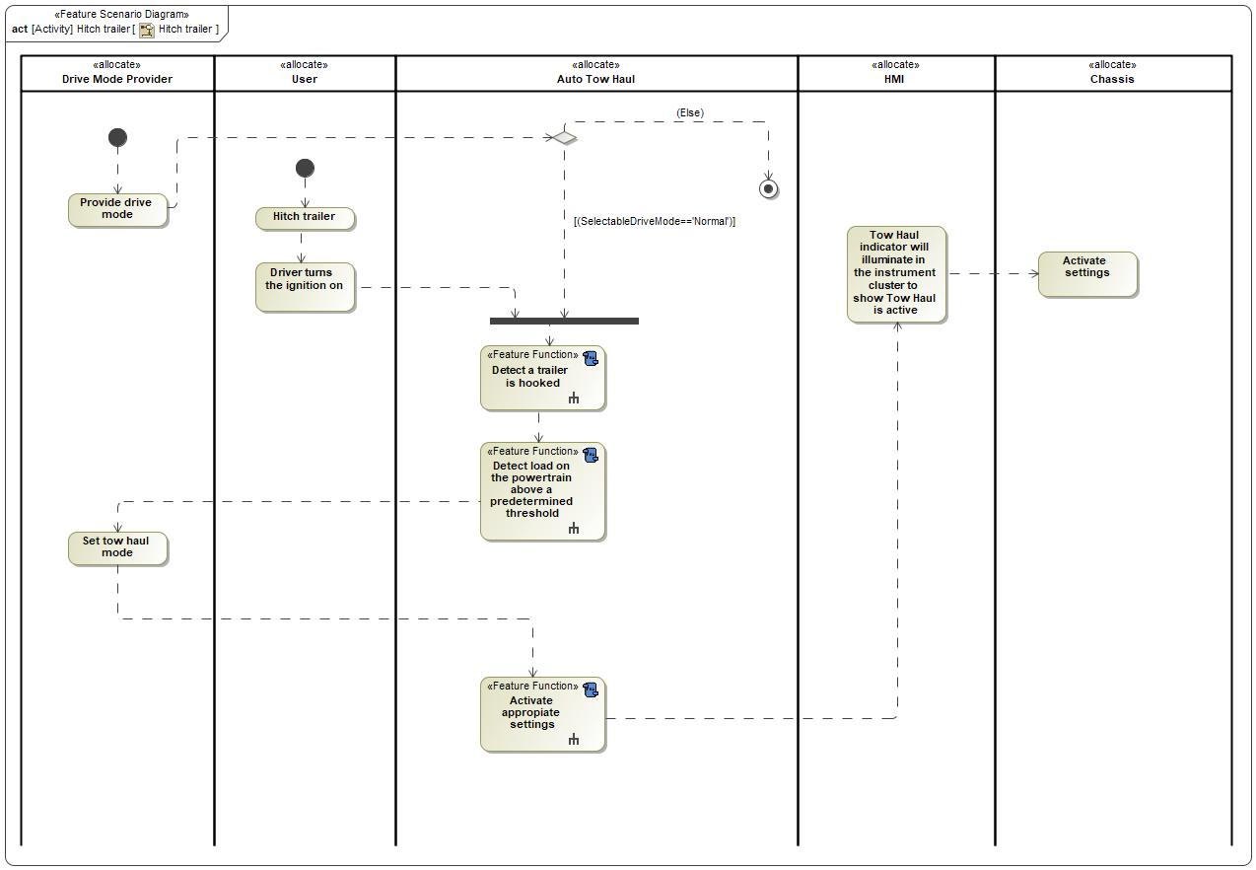

**Figure 4: Hitch Trailer**

|  |  |
| --- | --- |
| **Flow of Actions** | |
| 1 | Selectable Drive Mode |
| 2 | User; hitch the trailer |
| 3 | Auto Tow Haul; detects load above the threshold |
| 4 | IPC: Active drive mode is show in IPC via telltale |
| 5 | Chassis; appropriate suspension, TCCM and EPAs settings are applied |

**Table 18: Flow Actions**

Turn off Auto Tow Haul

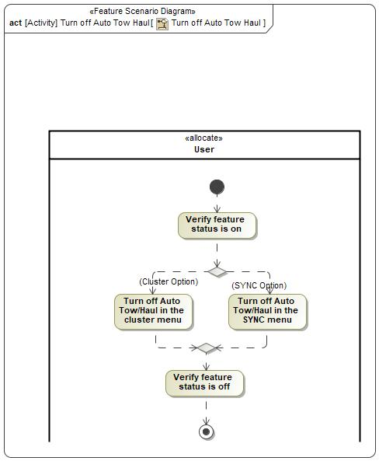

**Figure 5: Turn off Auto Tow Haul**

|  |  |
| --- | --- |
| **Flow of Actions** | |
| 1 | Verify feature status is on from HMI’s towing menu |
| 2 | Turn off Auto Tow Haul in the HMI’s towing menu |

**Table 19: Flow actions**

Turn on Auto Tow Haul

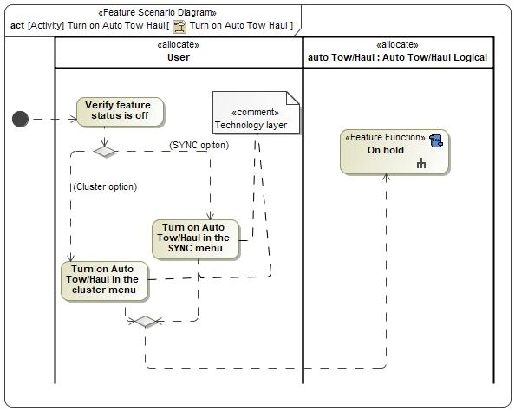

**Figure 6: Turn on Auto Tow Haul**

|  |  |
| --- | --- |
| **Flow of Actions** | |
| 1 | Verify feature status is Off from HMI’s towing menu |
| 2 | Turn on Auto Tow Haul in the HMI’s towing menu |

**Table 20: Flow of Action**

Unhitch trailer

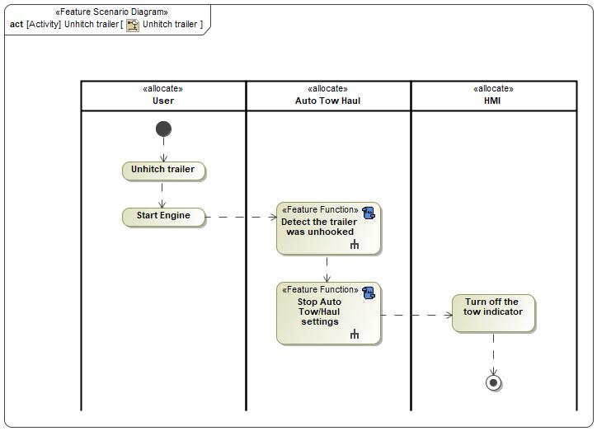

**Figure 7: Unhitch Trailer**

|  |  |
| --- | --- |
| **Flow of Actions** | |
| 1 | Driver unhitches the trailer |

**Table 21: Flow of Action**

## Feature Requirement

### ATH Ignition Status

The signal Ignition Status shall communicate the ignition status information of the vehicle.

The SDM CAN signal “Ignition Status” shall have the following signal properties:

|  |  |  |  |  |
| --- | --- | --- | --- | --- |
| **Name** | **Description** | **Transmitter** | **Receiver** | **Sampling Interval (ms)** |
| Ignition_Status | The processed value for current Ignition state. | BCM | ABS  SDM  PCM/ECM | 1000 E/P |

The Ignition Status signal shall communicate the possible ignition states via the following encoding:

|  |  |
| --- | --- |
| 0x0 | Unknown |
| 0x1 | Off |
| 0x2 | Accessory |
| 0x4 | Run |
| 0x8 | Start |
| 0xF | Invalid |

### Save ATH Settings

When the driver toggles either Off or Automatic, the ATH feature shall save the current status ATH functions to non-volatile memory

ATH-functions:

* SDM Mode
* AWD Drive Mode
* Powertrain Driveline
* Steering Mode
* Suspension Mode

### ATH Ignition Status

The signal Ignition Status shall communicate the ignition status information of the vehicle.

The SDM CAN signal “Ignition Status” shall have the following signal properties:

|  |  |  |  |  |
| --- | --- | --- | --- | --- |
| **Name** | **Description** | **Transmitter** | **Receiver** | **Sampling Interval (ms)** |
| Ignition_Status | The processed value for current Ignition state. | BCM | ABS  SDM  PCM/ECM | 1000 E/P |

The Ignition Status signal shall communicate the possible ignition states via the following encoding:

|  |  |
| --- | --- |
| 0x0 | Unknown |
| 0x1 | Off |
| 0x2 | Accessory |
| 0x4 | Run |
| 0x8 | Start |
| 0xF | Invalid |

### Display Saved Settings Information

When driver selects the towing menu option on the HMI, user shall be able to see the auto Tow haul saved settings.

## Functional Requirements

#### Error Handling

## Nonfunctional Requirement

ATH Regulation, the ATH feature shall NOT inhibit any regulatory requirements (NHTSA, CARB, OBD, Emissions, NCAP, Fuel label, etc.)

### ATH Feature Configuration

The ATH feature shall include a configuration to enable or disable the feature on vehicle

### HMI Requirements

#### **VS-SR-REQ-239164/E-Tow Haul**

For this feature when performing the “Set” or “Query” operation the Feature Number and Configuration Number in the Feature.Rq and Feature.St messages shall be used below.

If Enhanced Memory is supported the Active Personality Profile shall be used for PersIndex. If Enhanced Memory is not supported PersIndex shall be set to Vehicle.

|  |  |  |  |
| --- | --- | --- | --- |
| **Feature Description** | **Feature Number** | **Configuration Number** | **HMI Selection / Configuration Name** |
| Tow Haul | 0x0D02 | 0x00 | OFF / Disabled |
| 0x02 | Automatic |

Table 21: HMI selection

|  |  |
| --- | --- |
| SYNC Gen 3 Screen / ID HMI Number | HMI Setting ID |
| 2/39 | 224 |

Table 22: HMI settings ID

#### **Auto Tow-Haul Mode Activation**

There shall be no Auto Tow Haul adaptation when Auto Tow-Haul is deactivated by the driver in HMI settings.

#### **Tow-Haul Sub-Modes**

Auto Tow-Haul Feature shall utilize various algorithms and sensing technologies to adapt the vehicle behavior according to the trailer towing condition with regard to the driver selected drive mode.

#### **Auto Tow-Haul Mode**

Auto Tow-Haul Feature shall utilize various algorithms and sensing technologies to automatically select the most appropriate drive mode according to the trailer towing condition.

It shall be indicated to the driver when an automatically mode change is initialized.

### Other Requirements

#### **Manufacturing Requirements**

#### **Service Requirements**

##### **Service & Diagnostics**

The ATH feature configurable parameters shall be accessible by the Ford Authorized Diagnostic Tool

##### **After Sales Requirement**

##### **Owner’s Manual**

Vehicles equipped with ATH feature shall include the following information in the owner’s manual:

* ATH soft button illustration
* Activating ATH
* Saving ATH

|  |  |  |  |  |  |
| --- | --- | --- | --- | --- | --- |
| Requirement ID: ###R_F_MyMode_00007### | | | | | |
| **Rationale** |  | | | | | |
| **Acceptance Criteria** |  | | | | | |
| **Notes** |  | | | | | |
| **Source** |  | | | **Owner** |  | |
| **Source Req.** |  | | | **V&V Method** |  | |
| **Type** | Choose an item. | **Priority** | Choose an item. | **Status** | Choose an item. | |

## Functional Safety

### System Behaviors for HARA

|  |  |
| --- | --- |
| ID | Name |
| **F_ATH_0001** | Display Auto Tow Haul Settings |
| **F_ATH_0002** | Store Auto Tow Haul Settings |
| **F_ATH_0003** | Enable Auto Tow Haul Mode |
| **F_ATH_0004** | Detect Trailer in ‘Auto’ Auto Tow Haul Mode |

Table 23: System Behaviors for HARA

### Safety Assumptions

No Safety Assumptions applicable for the Auto Tow Haul Mode feature.

### Safety Goals

No Safety Goals applicable for the Auto Tow Haul Mode feature.

### Functional Safety Requirements

Functional Safety Requirements not applicable for Auto Tow Haul Mode.

### (Decomposed) Functional Safety Requirements

Decomposed FSRs not applicable for Auto Tow Haul Mode.

# FUNCTIONAL ARCHITECTURE

## Description

**This Functional Architecture**

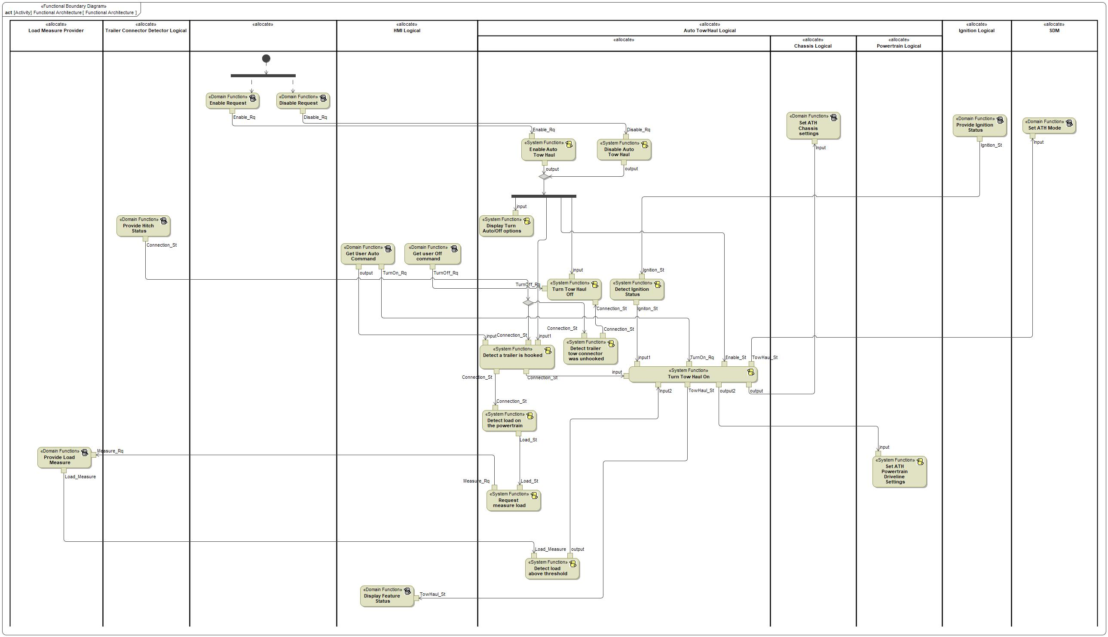

Figure 8: Functional Architecture

### List of Functions

| **Function Name** | Description | Comments |
| --- | --- | --- |
| *(activity)* Provide Ignition Status |  |  |
| *(activity)* Turn Tow Haul On |  |  |
| *(activity)* Detect Ignition Status |  |  |
| *(activity)* Set ATH Powertrain Driveline Settings |  |  |
| *(activity)* Get User Auto Command |  |  |
| *(activity)* Provide Hitch Status |  |  |
| *(activity)* Provide Load Measure |  |  |
| *(activity)* Turn Tow Haul Off |  |  |
| *(activity)* Enable Request |  |  |
| *(activity)* Detect a trailer is hooked |  |  |
| *(activity)* Disable Auto Tow Haul |  |  |
| *(activity)* Disable Request |  |  |
| *(activity)* Request measure load |  |  |
| *(activity)* Detect trailer tow connector was unhooked |  |  |
| *(activity)* Display Feature Status |  |  |
| *(activity)* Set ATH Mode |  |  |
| *(activity)* Display Turn Auto/Off options |  |  |
| *(activity)* Detect load above threshold |  |  |
| *(activity)* Enable Auto Tow Haul |  |  |
| *(activity)* Detect load on the powertrain |  |  |
| *(activity)* Get user Off command |  |  |
| *(activity)* Set ATH Chassis settings |  |  |

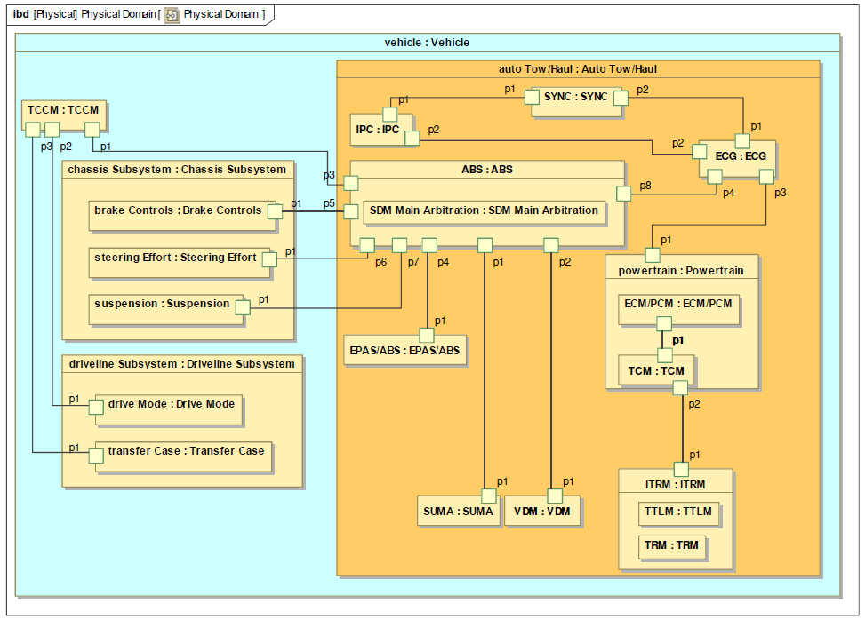

**Figure 9: Physical Domain Architecture**

## Logical Architecture

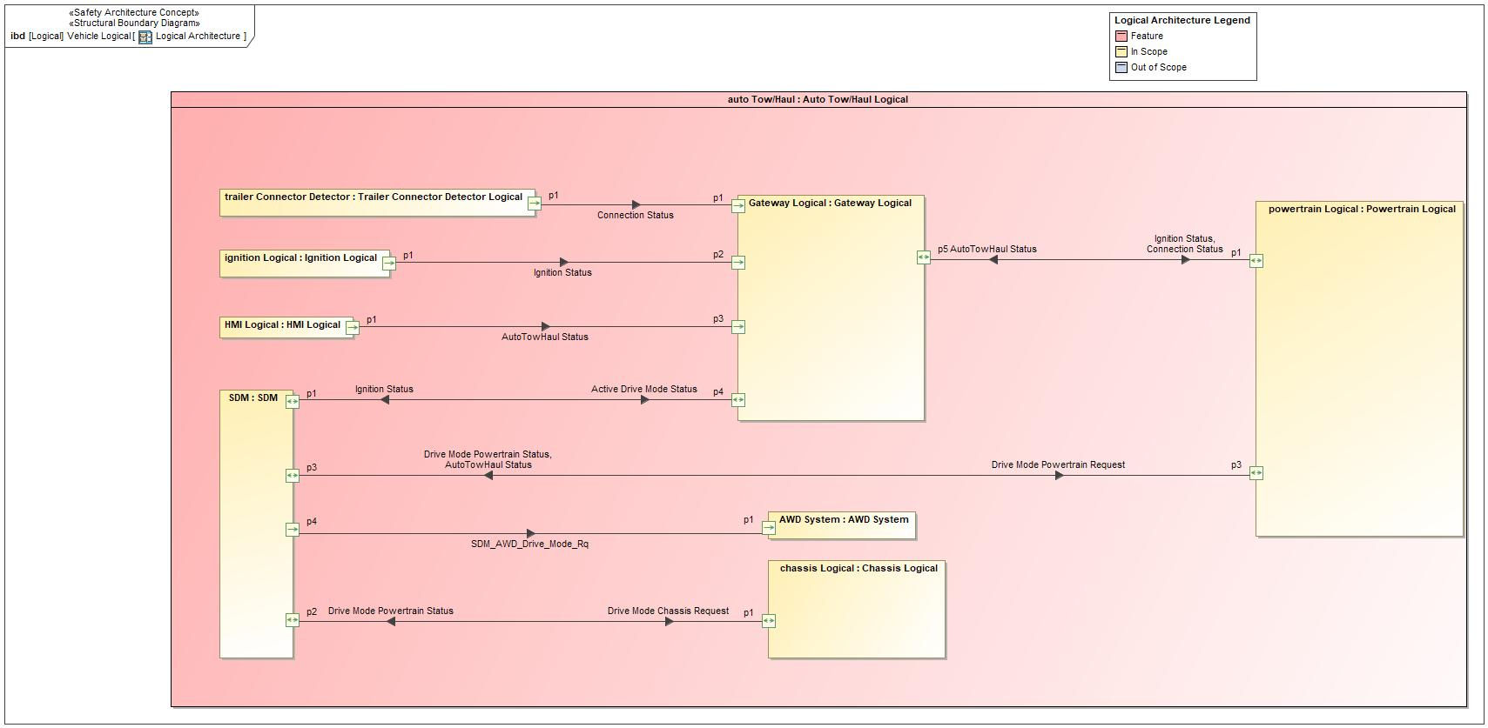

### Logical Elements

|  |  |  |  |
| --- | --- | --- | --- |
| **Element Name** | **Description** | **Allocated Functions** | **Comments** |
| Auto Tow/Haul Logical |  | * Detect a trailer is hooked * Detect Ignition Status * Detect load above threshold * Detect load on the powertrain * Detect trailer tow connector was unhooked * Disable Auto Tow Haul * Display Turn Auto/Off options * Enable Auto Tow Haul * Request measure load * Set ATH Chassis settings * Set ATH Powertrain Driveline Settings * Turn Tow Haul Off * Turn Tow Haul On |  |
| AWD System |  |  |  |
| Chassis Logical |  | * Set ATH Chassis settings |  |
| Gateway Logical |  |  |  |
| HMI Logical |  | * Display Feature Status * Get User Auto Command * Get user Off command |  |
| Ignition Logical |  | * Provide Ignition Status |  |
| Powertrain Logical |  | * Set ATH Powertrain Driveline Settings |  |
| SDM |  | * Set ATH Mode |  |
| Trailer Connector Detector Logical |  | * Provide Hitch Status |  |

### Logical Interfaces

|  |  |  |  |
| --- | --- | --- | --- |
| **Interface** | **Direction** | **Description** | **Value Range** |
| Active Drive Mode Status | p1 (SDM) To p4 (Gateway Logical) |  |  |
| AutoTowHaul Status | p1 (HMI Logical) To p3 (Gateway Logical) |  |  |
| p1 (Powertrain Logical) To p5 (Gateway Logical) |  |  |
| p3 (Powertrain Logical) To p3 (SDM) |  |  |
| Connection Status | p1 (Trailer Connector Detector Logical) To p1 (Gateway Logical) |  |  |
| p5 (Gateway Logical) To p1 (Powertrain Logical) |  |  |
| Drive Mode Chassis Request | p2 (SDM) To p1 (Chassis Logical) |  |  |
| Drive Mode Powertrain Request | p3 (SDM) To p3 (Powertrain Logical) |  |  |
| Drive Mode Powertrain Status | p1 (Chassis Logical) To p2 (SDM) |  |  |
| p3 (Powertrain Logical) To p3 (SDM) |  |  |
| Ignition Status | p1 (Ignition Logical) To p2 (Gateway Logical) |  |  |
| p4 (Gateway Logical) To p1 (SDM) |  |  |
| p5 (Gateway Logical) To p1 (Powertrain Logical) |  |  |
| SDM_AWD_Drive_Mode_Rq | p4 (SDM) To p1 (AWD System) |  |  |

## Function List

| Function # | Function Name | Description | Link to Function Spec | Comments |
| --- | --- | --- | --- | --- |
| F1 | ATH Arbitration and Processing | Arbitration of ATH requests based on ATH soft button input and feature configuration. This function also handles saving the ATH-function settings to memory and communicating the saved settings to other functions. |  | Existing Function  Turing the feature on or off but not a arbitrator |
| F2 | Powertrain Domain Arbitration | Provides the state of PT drive mode, exhaust mode, S/S ATH-functions and overwrite those functions to the saved ATH settings when requested |  | Existing Function |
| F3 | Chassis Domain Arbitration | Provides the state of the steering mode and suspension mode, ATH-functions. Also request the steering, suspension, stabilizer bar, and brakes ATH-functions to the saved ATH settings when requested |  | Existing Function |
| F4 | Driveline Domain Arbitration | Provides the state of AWD drive mode, driveline, front/rear e-locker ATH-functions and overwrites those functions to the saved ATH settings when requested |  | Existing Function |
| F5 | SDM Main Arbitration | Process the inputs from ATH function and determine when to change the base drive mode request to ATH mode |  | Existing Function |

Table 27: List of Logical Functions

# FUNCTION SPECIFICATIONS

## <F1> ATH Arbitration and Processing Function

### Function Overview

#### Description

The purpose of the ATH Arbitration and Processing function is the accomplish the following:

1. Arbitration of AutoTowActv_B_Stat signal state based on ATH switch input and communicating this signal state to other functions. This signal will request the following actions to other functions based on state:
   * Request SDM main arbitration function to change the base drive mode to ATH mode
   * Request IPC to overwrite their current active drive mode status (Telltale) with the Tow/Haul mode Telltale.
   * Request applicable domain functions to apply ATH Mode.
2. Arbitration of “Personality_APIM_Data” signal state and communicating to other functions.
   * This signal is used to communicate request for ATH messages that shall be shown on IPC (Telltale) to the display function.
3. SDM receives the status of ATH from its subsystems when requested and communicates the requested ATH mode back to PCM and IPC.

#### Input Requirements

#### Assumptions

#### References

#### Glossary

### Function Scope

### Function Interfaces

#### Logical Inputs

|  |  |
| --- | --- |
| **Signal Name** | **Description** |
| <(Mandatory) Word reference to the “Logical Signals” name bookmark in the Data Dictionary> | <(Optional) Word reference to the “Logical Signals” description bookmark in the Data Dictionary> |
|  |  |

#### Logical Outputs

|  |  |
| --- | --- |
| **Signal Name** | **Description** |
| <(Mandatory) Word reference to the “Logical Signals” name bookmark in the Data Dictionary> | <(Optional) Word reference to the “Logical Signals” description bookmark in the Data Dictionary> |
|  |  |

#### Logical Parameters

|  |  |
| --- | --- |
| **Signal Name** | **Description** |
| <(Mandatory) Word reference to the “Logical Signals” name bookmark in the Data Dictionary> | <(Optional) Word reference to the “Logical Signals” description bookmark in the Data Dictionary> |
|  |  |

### Function Modeling

#### Use Cases

#### State Charts / Activity Diagrams / Sequence Diagrams / Decision Tables

### Function Requirements

#### Functional Requirements

##### Normal Operation

##### Error Handling

#### Non-Functional Requirements

#### (Decomposed) Functional Safety Requirements

| Initial Safety Requirement | Functional Safety Requirement X | |
| --- | --- | --- |
| Decomposition Rationale |  | |
| Method for Decomposition | Choose a Method | |
| Technical Safety Requirement 1 after Decomposition | T-S-Req-ID |  |
| T-S-Req. Title |  |
| ASIL |  |
| Rationale |  |
| Technical Safety Requirement 2 after Decomposition | T-S-Req-ID |  |
| T-S-Req. Title |  |
| ASIL |  |
| Rationale |  |
| Technical Safety Requirement for Independence  *Note: should consider coATHonly used input, output and processing*  *Note: additional row should be added if additional* *requirements for Independence are necessary* | T-S-Req.-ID |  |
| T-S-Req. Title |  |
| ASIL |  |
| Rationale |  |

#### Other Requirements

##### Design Requirements

## Powertrain Domain Arbitration Function

### Function Overview

#### Description

The Purpose of the Powertrain Arbitration function is to perform the following:

1. The signal Powertrain Drive Mode Request shall communicate the drive mode request for the SDM interface powertrain.
2. Receive the ATH Mode saved settings for powertrain drive mode, the ATH Mode Arbitration and propagate the settings to each of the subsystems.
3. Request to overwrite state of each of those subsystems with ATH drive Mode, when SDM Main Arbitration is requesting Auto Tow Haul mode.

#### Variants

|  |  |
| --- | --- |
| **Signal Name** | **Description** |
| <(Mandatory) Word reference to the “Logical Signals” name bookmark in the Data Dictionary> | <(Optional) Word reference to the “Logical Signals” description bookmark in the Data Dictionary> |
| AutoTowAllw_D_RqMnu | Signal that communicates the ATH Mode request to all the functions that are in the ATH Mode system   |  |  |  | | --- | --- | --- | | **ASIL** | | QM | | **Encoding Type Name** | |  | | **Value**  (Discrete  Encoding) | 0x0 | NoSelection | | 0x1 | AutoTowHaulDisabled | | 0x2 | AutoTowHaulEnabled | | 0x3 | TowHaulCommandedOn | | **Unit** | | SED | |
| SelDrvMdePt_D_Rq | Signal that communicates the requested drive mode from the SDM feature to the powertrain system   |  |  |  | | --- | --- | --- | | **ASIL** | | QM | | **Encoding Type Name** | |  | | **Value**  (Discrete  Encoding) | 0x3 | TowHaulMode | | 0x1F | Faulty | | **Unit** | | SED | |
| AutoTowActv_B_Stat | Signal that communicates the saved Powertrain drive mode settings to ATH arbitrator   |  |  |  | | --- | --- | --- | | **ASIL** | | QM | | **Encoding Type Name** | |  | | **Value**  (Discrete  Encoding) | 0x0 | No | | 0x1 | Yes | | **Unit** | | SED | |

### Function Scope



Figure 10: Powertrain Domain Arbitration Function

### Function Interfaces

#### Logical Inputs

|  |  |  |  |  |
| --- | --- | --- | --- | --- |
| **Name** | **Description** | **Transmitter** | **Receiver** | **Sampling Interval (ms)** |
| SelDrvMdePt_D_Rq | The signal communicates the drive mode request for the SDM interface powertrain. | ABS | PCM/ECM, HVAC / FCIM | 1000 EP |

|  |  |
| --- | --- |
| **Signal Name** | **Description** |
| <(Mandatory) Word reference to the “Logical Signals” name bookmark in the Data Dictionary> | <(Optional) Word reference to the “Logical Signals” description bookmark in the Data Dictionary> |
| AutoTowAllw_D_RqMnu | Signal that communicates the ATH Mode request to all the functions that are in the ATH Mode system   |  |  |  | | --- | --- | --- | | **ASIL** | | QM | | **Encoding Type Name** | |  | | **Value**  (Discrete  Encoding) | 0x0 | NoSelection | | 0x1 | AutoTowHaulDisabled | | 0x2 | AutoTowHaulEnabled | | 0x3 | TowHaulCoATHanded On | | **Unit** | | SED | |
| SelDrvMdePt_D_Rq | Signal that communicates the requested drive mode from the SDM feature to the powertrain system   |  |  |  | | --- | --- | --- | | **ASIL** | | QM | | **Encoding Type Name** | |  | | **Value**  (Discrete  Encoding) | 0x3 | TowHaulMode | | 0x1F | Faulty | | **Unit** | | SED | |
| AutoTowActv_B_Stat | Signal that communicates the saved Powertrain drive mode settings to ATH arbitrator   |  |  |  | | --- | --- | --- | | **ASIL** | | QM | | **Encoding Type Name** | |  | | **Value**  (Discrete  Encoding) | 0x0 | No | | 0x1 | Yes | | **Unit** | | SED | |

#### Logical Outputs

|  |  |
| --- | --- |
| **Signal Name** | **Description** |
| <(Mandatory) Word reference to the “Logical Signals” name bookmark in the Data Dictionary> | <(Optional) Word reference to the “Logical Signals” description bookmark in the Data Dictionary> |
| AutoTowActv_B_Stat | Signal that communicates the saved Powertrain drive mode settings to ATH arbitrator   |  |  |  | | --- | --- | --- | | **ASIL** | | QM | | **Encoding Type Name** | |  | | **Value**  (Discrete  Encoding) | 0x0 | No | | 0x1 | Yes | | **Unit** | | SED | |

|  |  |  |  |  |
| --- | --- | --- | --- | --- |
| **Name** | **Description** | **Transmitter** | **Receiver** | **Sampling Interval (ms)** |
| SelDrvMdePt_D_Stat | Current drive mode status of SDM subsystem powertrain. | PCM/ECM | ABS | 1000 EP |

### Function Modeling

#### Use Case(s)

#### State Charts / Activity Diagrams / Sequence Diagrams / Decision Tables

### Function Requirements

#### **Functional Requirements**

##### **Normal Operation**

##### **Actual Status of Powertrain ATH-function**

When Ignition_Status = “RUN”, the Powertrain Arbitration shall continuously communicate the current state of the Powertrain Drive Mode via the output signals in the table below

|  |  |
| --- | --- |
| ATH-Function | Output Signal |
| Powertrain Drive Mode | SelDrvMdePt_D_Stat  AutoTowActv_B_Stat |

##### **Saved Settings for Powertrain ATH- Function**

When Ignition_Status = “RUN”, the Powertrain Arbitration shall receive the saved ATH settings for the Powertrain drive mode, ATH-functions via the input signals listed in the table below

|  |  |
| --- | --- |
| ATH-Function | Input Signal |
| Powertrain Drive Mode (TCM) | AutoTow_B_Inf |
| Powertrain Drive Mode | SelDrvMdePt_D_Stat |

##### **Transition to Normal to ATH**

When the Powertrain Arbitration function receives SelDrvMdePt_D_Rq = “Tow Haul , the Powertrain Arbitration function shall overwrite the current Powertrain Drive Mode with the ATH saved settings communicated via the input request signals

##### **Exit Conditions**

When the Powertrain Arbitration was previously receiving SelDrvMdePt_D_Rq = “TowHaul”, and the signal changes to SelDrvMdePt_D_Rq != ‘’TowHaul” (falling edge), the Powertrain Arbitration shall overwrite the current Powertrain Drive Mode, states based on the new Selectable Drive Mode State as commanded via SelDrvMdePt_D_Rq

|  |  |  |  |  |  |
| --- | --- | --- | --- | --- | --- |
| Requirement ID: ###R_FNC_Powertrain Arbitration_00006### | | | | | |
| **Rationale** |  | | | | | |
| **Acceptance Criteria** |  | | | | | |
| **Notes** |  | | | | | |
| **Source** |  | | | **Owner** |  | |
| **Source Req.** |  | | | **V&V Method** |  | |
| **Type** | Choose an item. | **Priority** | Choose an item. | **Status** | Choose an item. | |

#### Non-Functional Requirements

#### (Decomposed) Functional Safety Requirements

| Initial Safety Requirement | Functional/Technical Safety Requirement X | |
| --- | --- | --- |
| Decomposition Rationale |  | |
| Method for Decomposition | Choose a Method | |
| Technical Safety Requirement 1 after Decomposition | T-S-Req-ID |  |
| T-S-Req. Title |  |
| ASIL |  |
| Rationale |  |
| Technical Safety Requirement 2 after Decomposition | T-S-Req-ID |  |
| T-S-Req. Title |  |
| ASIL |  |
| Rationale |  |
| Technical Safety Requirement for Independence  *Note: should consider coATHonly used input, output and processing*  *Note: additional row should be added if additional* *requirements for Independence are necessary* | T-S-Req.-ID |  |
| T-S-Req. Title |  |
| ASIL |  |
| Rationale |  |

## <F3> Chassis Domain Arbitration Function

### Function Overview

#### Description

The Purpose of the Chassis Arbitration function is to perform the following:

1. Receive the ATH Mode request from powertrain drive mode to SDM and, the SDM Mode Arbitration will propagate the request to ATH to each of the subsystems.

* Steering drive mode
* Suspension drive mode

1. Communicate the current status of the steering mode and suspension mode back to the SDM.

### Function Scope



Figure 11: Chassis Arbitration Function Boundary Diagram

### Function Interfaces

#### Logical Inputs

|  |  |
| --- | --- |
| **Signal Name** | **Description** |
| <(Mandatory) Word reference to the “Logical Signals” name bookmark in the Data Dictionary> | <(Optional) Word reference to the “Logical Signals” description bookmark in the Data Dictionary> |
| SelDrvMdeChassis2_D_Rq | Signal that communicates the saved steering drive mode state for ATH Mode   |  |  |  | | --- | --- | --- | | **ASIL** | | QM | | **Encoding Type Name** | |  | | **Value**  (Discrete  Encoding) | 0xB | TowHaulMode | | 0x1F | Faulty | | **Unit** | | SED | |
| SelDrvMdeChassis_D_Rq | Signal that communicates the saved suspension drive mode state for MyMode   |  |  |  | | --- | --- | --- | | **ASIL** | | QM | | **Encoding Type Name** | |  | | **Value**  (Discrete  Encoding) | 0xB | TowHaulMode | | 0x1F | Faulty | | **Unit** | | SED | |

#### Logical Outputs

|  |  |
| --- | --- |
| **Signal Name** | **Description** |
| <(Mandatory) Word reference to the “Logical Signals” name bookmark in the Data Dictionary> | <(Optional) Word reference to the “Logical Signals” description bookmark in the Data Dictionary> |
| SelDrvMdePt_D_Stat | Signal that communicates the current state of the steering mode   |  |  |  | | --- | --- | --- | | **ASIL** | | QM | | **Encoding Type Name** | |  | | **Value**  (Discrete  Encoding) | 0x0 | NotAvailable | | 0x1 | Available | | 0x2 | TemporarilyNotAvailable | | 0x3 | Faulty | | **Unit** | | SED | |
| SelDrvMdeAirSusp_D_Stat | Signal that communicates the current state of the steering mode   |  |  |  | | --- | --- | --- | | **ASIL** | | QM | | **Encoding Type Name** | |  | | **Value**  (Discrete  Encoding) | 0x0 | NotAvailable | | 0x1 | Available | | 0x2 | TemporarilyNotAvailable | | 0x3 | Faulty | | **Unit** | | SED | |
| SelDrvMdeSusp_D_Stat | Signal that communicates the current state of the steering mode   |  |  |  | | --- | --- | --- | | **ASIL** | | QM | | **Encoding Type Name** | |  | | **Value**  (Discrete  Encoding) | 0x0 | NotAvailable | | 0x1 | Available | | 0x2 | TemporarilyNotAvailable | | 0x3 | Faulty | | **Unit** | | SED | |
| SelDrvMdeSte_D_Stat | Signal that communicates the current state of the steering mode   |  |  |  | | --- | --- | --- | | **ASIL** | | QM | | **Encoding Type Name** | |  | | **Value**  (Discrete  Encoding) | 0x0 | NotAvailable | | 0x1 | Available | | 0x2 | TemporarilyNotAvailable | | 0x3 | Faulty | | **Unit** | | SED | |

### Function Modeling

#### Use Cases

#### State Charts / Activity Diagrams / Sequence Diagrams / Decision Tables

### Function Requirements

#### **Functional Requirements**

##### **Communicate Status of Chassis ATH-functions**

When Ignition_Status = “RUN”, the Chassis Arbitration function shall communicate the status of the steering mode and suspension mode ATH-functions via the output signals in the table below

|  |  |
| --- | --- |
| ATH-Function | Output Signal |
| Steering Mode | SelDrvMdeSte_D_Stat |
| Dynamic Damping Suspension mode | SelDrvMdeSusp_D_Stat |
| Air Suspension mode | SelDrvMdeAirSusp_D_Stat |

##### **Receive Requested Settings for Chassis ATH-functions**

When Ignition_Status = “RUN”, the Chassis Arbitration function shall receive the saved ATH Mode settings for the chassis domain ATH-functions via the input signals in chart below

|  |  |
| --- | --- |
| Chassis Domain ATH-functions | ATH Mode Input Signals |
| Steering Mode | SelDrvMdeChassis2_D_Rq |
| Suspension mode | SelDrvMdeChassis_D_Rq |

##### **Transition to ATH mode**

When the Chassis Arbitration function receive SelDrvMdePt_D_Stat = “Available” from the SDM Main Arbitration, the Chassis Arbitration function shall request all enabled chassis ATH-functions to apply their settings to the ATH Mode, communicated via the input signals

##### Error Handling

***#Hint:*** *In this chapter requirements could be derived e.g. from “FMEA counter measures”*

#### Non-Functional Requirements

#### Other Requirements

##### Design Requirements

## <F4> Driveline Domain Arbitration Function

### Function Overview

#### Description

The Purpose of the Driveline Arbitration function is to perform the following:

1. The signal desired TCCM/DLCM Mode shall communicate the drive mode request for the SDM interface to TCCM/DLCM.
2. Receives the ATH Mode for the driveline domain ATH-function and Apply the Tow Haul Mode calibrations
3. Request subsystems to overwrite their current drive mode with the ATH when SDM Main Arbitration function is requesting to enter the Auto Tow Haul mode.
4. Communicate the actual status of the Tow Haul to the SDM Arbitration function

#### Input Requirements

#Classification: Mandatory (State “Not applicable”, if not used)

#Hint: List any input requirements here (legal, Trustmark), which need to be taken into account, beyond what is specified on feature level.

#### Assumptions

#Classification: Mandatory (State “Not applicable”, if not used)

#Hint: A list of known assumptions concerning the effects of the function’s behavior on other functions or elements (i.e., dependencies) as well as assumptions on the behavior expected by the function (e.g. known limitations). During the course of the development most of those assumptions are typically either converted into actual requirements or discarded at some point – such that this chapter remains mostly empty.

#### References

#Classification: Mandatory

#Hint: This may just be a reference to section “**References**” in section “*Feature DOCUMENT*”.

Refer to **2.1.7** “**References**”.

#### Glossary

#Classification: Mandatory”

#Hint: This may just be a reference to section “*Glossary*” in section “*Feature DOCUMENT*”.

Refer to 2.1.8 “Glossary”.

### Function Scope



**Figure** **12: Chassis Arbitration Function Boundary Diagram**

### Function Interfaces

#### Logical Inputs

|  |  |  |  |  |
| --- | --- | --- | --- | --- |
| **Name** | **Description** | **Transmitter** | **Receiver** | **Sampling Interval (ms)** |
| SelDrvMdeAwd_D_Rq | Drive mode request to TCCM | ABS | TCCM, AWD_DLCM, PCM/ ECM | 1000 EP |

|  |  |
| --- | --- |
| **Signal Name** | **Description** |
| <(Mandatory) Word reference to the “Logical Signals” name bookmark in the Data Dictionary> | <(Optional) Word reference to the “Logical Signals” description bookmark in the Data Dictionary> |
| SelDrvMdeAWD_D_Rq | Signal that communicates the requested drive mode from the SDM feature to the AWD system   |  |  |  | | --- | --- | --- | | **ASIL** | | QM | | **Encoding Type Name** | |  | | **Value**  (Discrete  Encoding) | 0x5 | TowHaulMode | | 0x1F | Faulty | | **Unit** | | SED | |

#### Logical Outputs

|  |  |
| --- | --- |
| **Signal Name** | **Description** |
| <(Mandatory) Word reference to the “Logical Signals” name bookmark in the Data Dictionary> | <(Optional) Word reference to the “Logical Signals” description bookmark in the Data Dictionary> |
| SelDrvMdePt_D_Stat | Signal that communicates the current state of the steering mode   |  |  |  | | --- | --- | --- | | **ASIL** | | QM | | **Encoding Type Name** | |  | | **Value**  (Discrete  Encoding) | 0x0 | NotAvailable | | 0x1 | Available | | 0x2 | TemporarilyNotAvailable | | 0x3 | Faulty | | **Unit** | | SED | |

### Function Modeling

#### Use Cases

#### State Charts / Activity Diagrams / Sequence Diagrams / Decision Tables

### Function Requirements

##### **SDM Selection Availability During Actuator Mode Changes**

SDM Feature shall allow drive mode selections if dedicated SDM actuators are in mode change transition states.

##### **Auto Tow Haul Mode Activation**

There shall be no Auto Tow Haul adaptation when Auto Tow-Haul is deactivated by the driver in HMI settings.

##### **Tow-Haul Sub-Modes**

Auto Tow-Haul Feature shall utilize various algorithms and sensing technologies to adapt the vehicle behavior according to the trailer towing condition with regard to the driver selected drive mode.

##### **Auto Tow-Haul Mode**

Auto Tow-Haul Feature shall utilize various algorithms and sensing technologies to automatically select the most appropriate drive mode according to the trailer towing condition.

It shall be indicating to the driver when a automatically mode change is initialized.

##### **Communicate Driveline ATH-function Status**

When Ignition_Status = “RUN”, the Driveline Arbitration function shall continuously communicate the current state of the driveline ATH-functions via the output signals listed in section 4.4.3.2 Logical Outputs

##### **Receive Saved ATH Settings for Driveline ATH-functions**

When Ignition_Status = “RUN”, the Driveline Arbitration function shall receive the saved ATH settings for the Tow haul via the input signals in section 4.4.3.1 Logical Inputs

##### **Transition to ATH Mode**

Arbitration function shall request all enabled TCCM ATH-functions to overwrite their settings to the saved ATH Mode settings When the Chassis Arbitration function receive SelDrvMdePt_D_Stat = “Available” from the SDM Main Arbitration, the Driveline Domain communicated via the ATH Mode input signals

##### **Override Conditions**

When the Powertrain Arbitration was previously receiving SelDrvMdePt_D_Rq = “TowHaulMode”, and the driveline are overridden by the driver the affected system shall follow the customer request, where the most recent customer request shall take priority

##### Error Handling

#### Non-Functional Requirements

#### Other Requirements

#Hint: Further requirements relevant from development process side could be listed in this section.

##### Design Requirements

***#Hint:*** *Requirements of a Logical Function should be typically agnostic of their SW/HW implementation*. If for specific reasons the function owner needs to define explicitly design constraints, it can be done in this chapter.

## <F5> SDM Main Arbitration Function

### Function Overview

#### Description

The Purpose of the SDM Main Arbitration function is to perform the following:

1. Change the base drive mode request to “Auto Tow Haul” when ATH Arbitration function requests to activate ATH Mode

#### Input Requirements

#### Assumptions

#### References

#### Glossary

### Function Scope

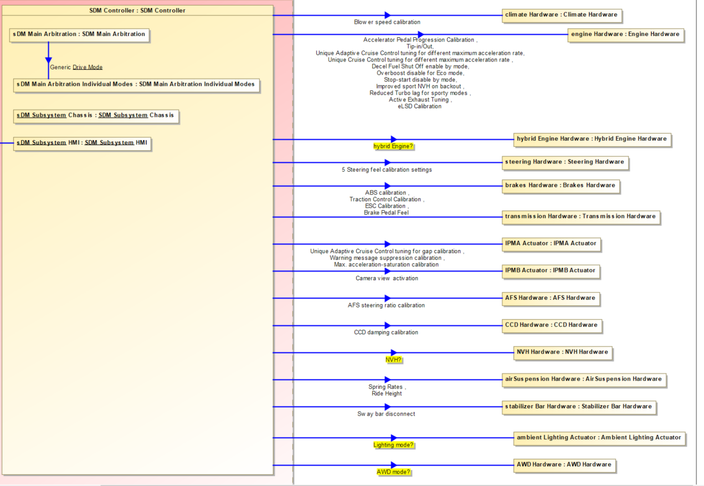

### Function Interfaces

#### Logical Inputs

|  |  |  |
| --- | --- | --- |
| **Signal Name** | | **Description** |
| <(Mandatory) Word reference to the “Logical Signals” name bookmark in the Data Dictionary> | | <(Optional) Word reference to the “Logical Signals” description bookmark in the Data Dictionary> |
| AutoTowAllw_D_RqMnu | | Signal that communicates the ATH Mode request to all the functions that are in the ATHMode system   |  |  |  | | --- | --- | --- | | **ASIL** | | QM | | **Encoding Type Name** | |  | | **Value**  (Discrete  Encoding) | 0x0 | NoSelection | | 0x1 | AutoTowHaulDisabled | | 0x2 | AutoTowHaulEnabled | | 0x3 | TowHaulCoATHanded On | | **Unit** | | SED | |
| SelDrvMdePt_D_Rq | | Signal that communicates the saved ATH Mode to Powertrain Mode   |  |  |  | | --- | --- | --- | | **ASIL** | | QM | | **Encoding Type Name** | |  | | **Value**  (Discrete  Encoding) | 0x3 | TowHaulMode | | 0x1F | Faulty | | **Unit** | | SED | |
| SelDrvMdeChassis2_D_Rq | Signal that communicates the saved steering drive mode state for ATH Mode   |  |  |  | | --- | --- | --- | | **ASIL** | | QM | | **Encoding Type Name** | |  | | **Value**  (Discrete  Encoding) | 0xB | TowHaulMode | | 0x1F | Faulty | | **Unit** | | SED | | |
| SelDrvMdeChassis_D_Rq | Signal that communicates the saved suspension drive mode state for ATH Mode   |  |  |  | | --- | --- | --- | | **ASIL** | | QM | | **Encoding Type Name** | |  | | **Value**  (Discrete  Encoding) | 0xB | TowHaulMode | | 0x1F | Faulty | | **Unit** | | SED | | |

#### Logical Outputs

|  |  |
| --- | --- |
| **Signal Name** | **Description** |
| <(Mandatory) Word reference to the “Logical Signals” name bookmark in the Data Dictionary> | <(Optional) Word reference to the “Logical Signals” description bookmark in the Data Dictionary> |
| SelDrvMdePt_D_Rq | Signal that communicates the requested drive mode from the SDM feature to the Powertrain system   |  |  |  | | --- | --- | --- | | **ASIL** | | QM | | **Encoding Type Name** | |  | | **Value**  (Discrete  Encoding) | 0x3 | TowHaulMode | | 0x1F | Faulty | | **Unit** | | SED | |
| SelDrvMdePt_D_Stat | Signal that communicates the requested drive mode from the SDM feature to the Steering and suspension modes to SDM   |  |  |  | | --- | --- | --- | | **ASIL** | | QM | | **Encoding Type Name** | |  | | **Value**  (Discrete  Encoding) | 0x0 | NotAvailable | | 0x1 | Available | | 0x2 | TemporarilyNotAvailable | | 0x3 | Faulty | | **Unit** | | SED | |

#### Logical Parameters

|  |  |
| --- | --- |
| **Parameter Name** | **Description** |
| <(Mandatory) Word reference to the “Logical Parameters” name bookmark in the Data Dictionary> | <(Optional) Word reference to the “Logical Parameters” description bookmark in the Data Dictionary> |
|  |  |

### Function Modeling

#### Use Cases

#### State Charts / Activity Diagrams / Sequence Diagrams / Decision Tables

### Function Requirements

#### Functional Requirements

##### **SDM Selection Availability During Actuator Mode Changes**

SDM Feature shall allow drive mode selections if dedicated SDM actuators are in mode change transition states.

##### **Auto Tow Haul Mode Activation**

There shall be no Auto Tow Haul adaptation when Auto Tow-Haul is deactivated by the driver in HMI settings.

##### **Auto Tow Haul communication**

In order to ensure that there is no Auto Tow Haul adaptation when Auto Tow-Haul is deactivated by the driver in HMI settings, the following communication setup shall be used:

- SDM Main Arbitration shall always response to the external Auto Tow-Haul Feature.

- External Auto Tow-Haul Feature shall utilize various algorithms and sensing technologies to detect a trailer towing condition and only communicate a trailer detection when the feature is activated via HMI.

##### **Auto Tow Active Status CAN Signal Determination**

The external Auto Tow-Haul Feature shall arbitrate the feature activation menu and the trailer detection algorithms.

The signal Auto Tow-Haul detect shall be set to True if a trailer is detected and the feature is enabled. It shall be false in all other cases.

The trailer detection by the external feature shall be done in all drive modes and the drive mode specific handling shall be arbitrated by the SDM Main Software.

##### **Auto Tow Active Status Start-up Behavior**

Auto Tow Active Status CAN Signal shall initialize to 0 on key cycle.

##### **Auto Tow Active Status Integration Signal Content**

The Auto Tow Active Status integration signal shall communicate the status of the Auto Tow-Haul feature via the following encoding:

State Encoding Description

0x0 Auto Tow inactive Auto Tow intreraction are inactive

0x1 Auto Tow active Auto Tow interaction shall executed according to mode calibration

The content of the integration signal Auto Tow Active Status shall be set besed on the Tow Active Status CAN signal and the SDM Configuration Parameter (DID):

Configuration Value Handling

0x0 Disabled No DTC handling for Auto Tow Active Status CAN Signal

sdm_b_autotow_stat = 0

0x1 Enabled DTC handling for Auto Tow Active Status CAN Signal

sdm_b_autotow_stat = AutoTowHaul_B_Sta.

sdm_b_autotow_stat = 0, if CAN signal has timed out (including: No data exists;

Checksum error) or the ABSmodule is not listed as a receiver of the CAN signal.

Note:

Internal Signal: sdm_b_autotow_stat

##### **Tow-Haul Sub-Mode**

Auto Tow-Haul Feature shall utilize various algorithms and sensing technologies to adapt the vehicle behavior according to the trailer towing condition with regard to the driver selected drive mode.

##### **Active Drive Mode Translation To Subsystem(s): Auto Tow-Haul**

SDM Main Arbitration shall have a calibration parameter for the subsystem Chassis and one for the subsystem Powertrain to define which drive mode shall be requested when Auto Tow-Haul is active.

|  |  |  |  |  |  |  |
| --- | --- | --- | --- | --- | --- | --- |
| Drive Mode | AutoTowHaul_B_Stat == 0 (Auto Tow/Haul off or no trailer) | | | AutoTowHaul_B_Stat == 1 (Auto Tow/Haul on and trailer) | | |
| Chassis | Powertrain | Drive Line | Chassis | Powertrain | Drive Line |
| Excite | Sport | Sport | Sport | Sport | Sport | Sport |
| Conserve | Economy | Economy | Economy | Tow Haul | Economy | Economy |
| Normal | Normal | Normal | Normal | Tow Haul | Tow Haul | Normal |
| Slippery | Slippery | Slippery | Slippery | Tow Haul | Slippery | Slippery |
| Sand | Sand | Sand | Sand | Tow Haul | Sand | Sand |

**Use Cases**

1. Driver connects a trailer and select Slippery mode

|  |  |
| --- | --- |
| **SDM** | |
| Cluster | Slippery |
| Chassis | Slippery |
| Powertrain | Slippery |

1. Trailer detected after some time driving (Auto Tow light on)

|  |  |
| --- | --- |
| **SDM** | |
| Cluster | Slippery |
| Chassis | Tow/haul |
| Powertrain | Slippery |

1. *“Switching to Normal Drive Mode for best towing,*

*Press OK to cancel”*

Scenario A: After 10seconds

SDM changes to Normal mode AND Powertrain activates Tow/Haul

|  |  |
| --- | --- |
| SDM | |
| Cluster | Normal |
| Chassis | Tow/haul |
| Powertrain | Tow/haul |

Scenario B: Press OK

SDM remains in Slippery BUT Chassis Domain remains in Tow/Haul

|  |  |
| --- | --- |
| SDM | |
| Cluster | Slippery |
| Chassis | Tow/haul |
| Powertrain | Slippery |

##### **Drive Mode Change Request via External Feature**

SDM Feature shall be capable to change the active drive mode via request of the following external features:

- Auto Tow-Haul.

There shall be a calibration parameter for each drive mode, which enable/disable external features to exit the mode. To avoid hardware shifting without driver input, the original and final drive mode shall have the same driveline setup.

The driver shall be informed, for example through warning message, before SDM Feature changes the active drive mode.



##### **Auto Tow-Haul Mode: Configuration**

SDM Main Arbitratiopn shall have a calibration parameter for each drive mode, enabling Auto Tow-Haul geature to exit the drive mode.

##### **Auto Tow-Haul Mode Handling**

When Auto Tow Active Status rises to Active and only if the current active drive mode is calibrated as Auto Tow-Haul Enabled, SDM Main Arbitration shall first request SDM Display to display the warning message Change_To_Normal (W3633) and subsequently initiate a drive mode change request.

The destiny drive mode shall be calibratable and dependent from active 4x4 state.

##### **Arbitration of Drive Mode Change Request from External Feature**

SDM Main Arbitration shall wait for suppressions event, as Shifting in progress and ABS suppression, and ongoing drive mode change requests to be finalized bevor handling the drive mode request from the external features.

##### **Cancelation of Drive Mode Change Request from External Feature**

SDM Main Arbitration shall cancel the drive mode change request from the external feature if the driver uses the SDM Switch after the warning message Change_To_Normal (W3633) is requested and before any system starts to change the drive mode.

##### **Auto Tow-Haul Mode**

Auto Tow-Haul Feature shall utilize various algorithms and sensing technologies to automatically select the most appropriate drive mode according to the trailer towing condition.

It shall be indicate to the driver when a automatically mode change is initialized.

##### **SDM** **Main Arbitration Input signals**

When Ignition_Status = “RUN”, the SDM Main Arbitration function shall receive all the input signals listed in the logical inputs section

##### **ATH Activate Request**

When the Powertrain receives AutoTowAllw_D_RqMnu= “(0x2) AutoTowHaulEnabled” (rising edge) from the HMI, Powertrain requests the SDM Main Arbitration to change the active drive mode request to all domain functions to the “Tow Haul” value per the table below.

|  |  |
| --- | --- |
| Domain Function | Drive Mode Request Signal |
| Powertrain | SelDrvMdePt_D_Rq |
| Chassis | SelDrvMdeChassis_D_Rq  SelDrvMdeChassis2_D_Rq |
| Sound | SelDrvMdeHmi04_D_Rq |

|  |  |  |  |  |  |
| --- | --- | --- | --- | --- | --- |
| Requirement ID: ###R_FNC_SDM Arbitration_00041### | | | | | |
| **Rationale** |  | | | | | |
| **Acceptance Criteria** |  | | | | | |
| **Notes** |  | | | | | |
| **Source** |  | | | **Owner** |  | |
| **Source Req.** |  | | | **V&V Method** |  | |
| **Type** | Choose an item. | **Priority** | Choose an item. | **Status** | Choose an item. | |

##### Error Handling

#### Non-Functional Requirements

#### Other Requirements

##### Design Requirements



# Feature IMPLEMENTATION SPECIFICATION

## Feature Implementation Overview

### Description

### Input Requirements

### Assumptions

### References

### Glossary

## Functional Architecture

## Physical Architecture

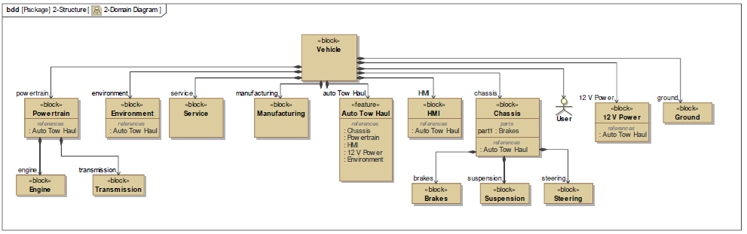

### E/E Architecture

#### E/E Architecture Variants

|  |  |  |
| --- | --- | --- |
| E/E Architecture Variant Name | Variant Description | Variant Condition (optional) |
| e.g “FNV2” |  | Example:   * VOpt_NetworkTopology = FNV2   AND   * DATGen = 2.0 |
| e.g. “CGEA Low Content” |  | Example:   * (VOpt_NetworkTopology = CGEA13   OR  VOpt_NetworkTopology = CGEA11)  AND   * VOpt_ABS = None   AND   * VOpt_PTModule = ECM |
|  |  |  |
|  |  |  |
|  |  |  |
|  |  |  |

##### E/E Architecture “Architecture Variant 1”



Figure 10: “E/E Architecture Variant 1”

Figure 11: “E/E Architecture Variant 1”

##### E/E Architecture “Architecture Variant 2”

#### E/E Components

#### E/E Connections

#### Signal List

| **Requirement Name** | **Functional Requirement** (i.e. what should the feature do?) | **Rationale/Source of Requirement** (why does the feature need to do this ?) |
| --- | --- | --- |
|
|  |
|
|
| PtMdeArb_D_Rq | Driver Mode Manager logic shall indicate Tow Haul is active through existing powertrain driver mode signal PtMdeArb_D_Rq . | 1) Desire to have feature coordinated with existing driver mode manager logic. 2) Maintains common architecture to transmission/engine controls for commanding "tow haul". |
| PtMdeArb_D_Rq (Tow) | PtMdeArb_D_Rq shall indicate "Tow Haul" (3) when: 1) AutoTowActv_B_Stat = 1 (active). 2) Current Selectable Drive Mode is set to "Normal/Auto" 3) Not in 4x4L 4) Not in HDC (Hill Descent Control) | 1) Auto Tow detected 2) Inferred from AutoTowActv_B_Stat conditions 3) Inferred from AutoTowActv_B_Stat conditions 4) HDC currently overrides Tow Haul. It only operates at very low speeds, and it would be desired to continue to keep Telltale on if HDC was active while Tow Haul was inferred so this is NOT included in the AutoTowActv_B_Stat calculation. |
| PtMdeArb_D_Rq (Others) | All other requirements associated with this signal are captured elsewhere due to the complexity of the number of systems involved with this calculation. | 1) Trying to provide both the link of Auto Tow Haul Requirement on this signal while still referencing the overall spec. |

## AutoTowAllw_D_StatMnu

|  |  |  |
| --- | --- | --- |
| Name: AutoTowAllw_D_StatMnu | | ID/Revision: auto-assigned  Type: auto-assigned |
| Description: (MS Word Rich Text) | | |
| CAN Node Type: | Signal Domain: | Signal Transmit Strategy:  Event Periodic |
| Signal Send Type:  OnChange | Signal Transmit Cycle Time(ms):  100 | End-to-End Latency Requirements(ms):  100 |
| Electrical Architecture:  This multi-value attribute cannot be updated in Word Live, use Rich Client or Excel to update | Lead Vehicle Program: | Other Vehicle Program:  This multi-value attribute cannot be updated in Word Live, use Rich Client or Excel to update |
|  |  |  |

#### **AutoTowAllw_D_StatMnu**

| **Requirement Name** | **Functional Requirement** (i.e. what should the feature do?) | **Rationale/Source of Requirement** (why does the feature need to do this ?) |
| --- | --- | --- |
|
|  |
|
|
| AutoTowAllw_D_StatMnu | PCM/ECM shall support an state output indicating the status of the customer menu selection for the Auto Tow system for indicating when Auto Tow would be allowed/coATHanded by the customer if the feature has not been disabled for other reasons (See requirements on AutoTowActv_B_Stat). | 1) Storage of mode in PCM/ECM instead of cluster to allow local control of initial condition in plant. 3) While the "AutoTow_B_Inf" signal will be able to distinguish if a load is present, the customer may still want to override that, and the menu allows for that option. |
| AutoTowAllw_D_StatMnu States | PCM/ECM shall support the following states: ENCODING:  0 = NoSelection  1 = Auto Tow Haul Disabled  2 = Auto Tow Haul Enabled  3 = Tow Haul CoATHanded ON |  |
| AutoTowAllw_D_StatMnu State (NoSelection) | PCM/ECM shall initialize to a state of NoSelection (0) when any of the following conditions are true: 1) Initial value when module is first flashed. 2) Memory fault is present indicating stored value is compromised. 3) Auto Tow Haul feature has been disabled in calibration. | 1) Allow for default mode to be selected via calibration for in plant default. 2) FMEM 3) Ensure signal is not allowed to activate if not configured. |
| AutoTowAllw_D_StatMnu State (Auto Tow Haul Disabled) | PCM/ECM shall send state of Auto Tow Haul Disabled (1) when any of the following conditions are true:1) Ignition Key is in OFF or Accesory state, and the current AutoTowAllw_D_StatMnu = Tow Haul On, and the AutoTowAllw_D_StatMnu state prior to On was Auto Tow Haul Disabled.2) AutoTowAllw_D_RqMnu = Auto Tow Haul Disabled3) Current AutoTowAllw_D_StatMnu = NoSelection and Calibration Default Mode = Auto Tow Haul DisabledNote: Conditions for "NoSelection" state take priority over being able to enter this state. | 1a) There are EPA regulations against maintaining a drive mode of Tow Haul On over a key cycle.1b) There is a desire to maintain last selected state prior to "On" upon key cycle.2) ECM learns a customer selected value.3) ECM supports default value in plant. (Expected to set default = "Auto Tow Haul Enabled", but provide as calibration parameter just in case.) |
| AutoTowAllw_D_StatMnu State (Auto Tow Haul Enabled) | PCM/ECM shall send state of Auto Tow Haul Enabled (2) when any of the following conditions are true: 1) Ignition Key is in OFF or Accessory state, and the current AutoTowAllw_D_StatMnu = Tow Haul On, and the AutoTowAllw_D_StatMnu state prior to On was Auto Tow Haul Enabled. 2) AutoTowAllw_D_RqMnu = Auto Tow Haul Enabled 3) Current AutoTowAllw_D_StatMnu = NoSelection and Calibration Default Mode = Auto Tow Haul Enabled  Note: Conditions for "NoSelection" state take priority over being able to enter this state. | 1a) There are EPA regulations against maintaining a drive mode of Tow Haul On over a key cycle. 1b) There is a desire to maintain last selected state prior to "On" upon key cycle. 2) ECM learns a customer selected value. 3) ECM supports default value in plant. (Expected to set default = "Auto Tow Haul Enabled” but provide as calibration parameter just in case.) |
|  |  |  |
| AutoTowAllw_D_StatMnu State (Tow Haul On) | ECM/PCM shall send state of Tow Haul On (3) when all of the following conditions are true:1) Ignition Key is NOT in the OFF or Accessory state2) AutoTowAllw_D_RqMnu = Tow Haul On3) Cluster is configured to support Auto TowNote: Conditions for All other states take priority over this state. | 1) There are EPA regulations against maintaining a drive mode over a key cycle.2) Prevent ECM from incorrectly learning a value not selected by the customer. |
| AutoTowAllw_D_StatMnu FMEM | Shall initialize to 0 on detection of a Memory fault.  No other faults are required to be detected, and no other action required due to other faults. |  |
| AutoTowAllw_D_StatMnu Initial value | In general, AutoTowAllw_D_StatMnu shall maintain its value over the key cycle. The exception being that the Tow Haul On state shall NOT be maintained. Further requirements associated with each state relative to initial values are captured in the specific State requirements. | 1) EPA regulations require power-up in "Normal" mode. |

### AutoTowAllw_D_StatMnu PCM/ECM

|  |  |  |  |
| --- | --- | --- | --- |
| Name: AutoTowAllw_D_StatMnu | | ID/Revision: auto-assigned  Type: auto-assigned | |
| Description: (MS Word Rich Text)  Current menu status from ECM/PCM indicating driver selected preference for the Auto Tow Haul feature. Represents a stored value across key cycle of AutoTowAllw_D_RqMnu.  ENCODING:  0 = NoSelection  1 = Auto Tow Haul Disabled  2 = Auto Tow Haul Enabled  3 = Tow Haul Commanded ON | | | |
| Publishing ECU:  ECM | ECU Options:  This multi-value attribute cannot be updated in Word Live, use Rich Client or Excel to update | ECU Power Mode:  Run/Start | |
| Publishing Feature:  This special attribute cannot be updated in Word Live, use Rich Client or Excel to update | Publishing Function:  This special attribute cannot be updated in Word Live, use Rich Client or Excel to update | | |
| Network/Latency | | | |
| Source Networks:  This multi-value attribute cannot be updated in Word Live, use Rich Client or Excel to update | Publishing Interval(ms):  15 | Publisher Latency Requirements(ms):  100 | |
| Publishing Network Sleep Inhibitor: | Network Wake Up:  ECU Reset | Signal Refresh Rate(ms):  8 | |
| Updates Signal While Asleep:  No | Fresh data on Network wakeup:  Yes | Max latency before signal is valid on Network wakeup(ms):  250 | |
| Fresh data on ECU Reset:  Yes | Max latency before signal is valid on reset(ms):  250 | | |
| Signal Robustness and Integrity | | | |
| Functional Safety Relevant:  No | ASIL: | | Checksum:  No |
| Counter:  No | Quality Factor:  No | | |
| Voltage Requirements | | | |
| Minimum Functional Voltage(V): | Maximum Functional Voltage(V): | | |
| Minimum Performance Voltage(V): | Maximum Performance Voltage(V): | | |

### AutoTowAllw_D_StatMnu IPC

|  |  |  |  |
| --- | --- | --- | --- |
| Name: AutoTowAllw_D_StatMnu | | ID/Revision: auto-assigned  Type: auto-assigned | |
| Description: (MS Word Rich Text)  Current menu status from ECM/PCM indicating driver selected preference for the Auto Tow Haul feature. Represents a stored value across key cycle of AutoTowAllw_D_RqMnu.  ENCODING:  0 = NoSelection  1 = Auto Tow Haul Disabled  2 = Auto Tow Haul Enabled  3 = Tow Haul Commanded ON | | | |
| Subscribing ECU:  IPC | ECU Options:  This multi-value attribute cannot be updated in Word Live, use Rich Client or Excel to update | ECU Power Mode: | |
| Subscribing Features:  This multi-value attribute cannot be updated in Word Live, use Rich Client or Excel to update | Subscribing Functions:  This multi-value attribute cannot be updated in Word Live, use Rich Client or Excel to update | | |
| Network/Latency | | | |
| Destination Networks:  This multi-value attribute cannot be updated in Word Live, use Rich Client or Excel to update | Subscribing Interval (ms): | Subscriber Latency Requirements (ms): | |
| Subscribing Network Sleep Inhibitor: | Network Wake Up: | Gateway Required:  Yes | |
| Max Gateway Latency (ms):  50 | Gateway Message Type: | | |
| Missing Message Diagnostics | | | |
| Missing Message Strategy:  Last Signal Value | Missing Message DTC: | Use Default Value when Missing Message: | |
| Missing Message Default Value: | Use Last Signal Value when Missing Message:  Yes | Timeout period when Last Signal Value not used for Missing Message (ms): | |
| Signal Robustness and Integrity | | | |
| Functional Safety Relevant:  No | ASIL: | | Checksum:  No |
| Counter:  No | Quality Factor:  No | | |
| Voltage Requirements | | | |
| Minimum Functional Voltage (V): | Maximum Functional Voltage (V): | | |
| Minimum Performance Voltage (V): | Maximum Performance Voltage (V): | | |

## AutoTowAllw_D_RqMnu

|  |  |  |
| --- | --- | --- |
| Name: AutoTowAllw_D_RqMnu | | ID/Revision: auto-assigned  Type: auto-assigned |
| Description: (MS Word Rich Text) | | |
| CAN Node Type: | Signal Domain: | Signal Transmit Strategy:  Event Periodic |
| Signal Send Type:  OnChange | Signal Transmit Cycle Time(ms): | End-to-End Latency Requirements(ms):  100 |
| Electrical Architecture:  This multi-value attribute cannot be updated in Word Live, use Rich Client or Excel to update | Lead Vehicle Program: | Other Vehicle Program:  This multi-value attribute cannot be updated in Word Live, use Rich Client or Excel to update |

#### **AutoTowAllw_D_RqMnu**

| **Requirement Name** | **Functional Requirement** (i.e. what should the feature do?) | **Rationale/Source of Requirement** (why does the feature need to do this ?) |
| --- | --- | --- |
|
|  |
|
|
| AutoTowAllw_D_RqMnu | Instrument cluster shall support an state output indicating the requested customer menu selection for the Auto Tow system for indicating when Auto Tow would be allowed/commanded by the customer if the feature has not been disabled for other reasons (See requirements on AutoTowActv_B_Stat). | 1) IC has direct access to menu screens/5 way switch. 2) Storage of mode in PCM/ECM instead of cluster to allow local control of initial condition in plant. 3) While the "AutoTow_B_Inf" signal will be able to distinguish if a load is present, the customer may still want to override that, and the menu allows for that option. |
| AutoTowAllw_D_RqMnu States | Cluster shall support the following states: ENCODING:  0 = NoSelection  1 = Auto Tow Haul Disabled  2 = Auto Tow Haul Enabled  3 = Tow Haul Commanded ON |  |
| AutoTowAllw_D_RqMnu State (NoSelection) | Cluster shall send state of NoSelection (0) when any of the following conditions are true: 1) Ignition Key is in the OFF or Accessory state 2) Customer has not manually selected another state 3) Cluster is configured not to support Auto Tow | 1) There are EPA regulations against maintaining a drive mode over a key cycle. 2) Prevent ECM from incorrectly learning a value not selected by the customer. 3) Ensure signal is not allowed to activate if not configured. |
|  |  |  |
| AutoTowAllw_D_RqMnu State (Auto Tow Haul Disabled) | Cluster shall send state of Auto Tow Haul Disabled (1) when all of the following conditions are true: 1) Ignition Key is NOT in the OFF or Accessory state 2) Customer has manually selected Auto Tow Haul Disabled 3) Cluster is configured to support Auto Tow | 1) There are EPA regulations against maintaining a drive mode over a key cycle. 2) Prevent ECM from incorrectly learning a value not selected by the customer. |
| AutoTowAllw_D_RqMnu State (Auto Tow Haul Enabled) | Cluster shall send state of Auto Tow Haul Enabled (2) when all of the following conditions are true: 1) Ignition Key is NOT in the OFF or Accessory state 2) Customer has manually selected Auto Tow Haul Enabled 3) Cluster is configured to support Auto Tow | 1) There are EPA regulations against maintaining a drive mode over a key cycle. 2) Prevent ECM from incorrectly learning a value not selected by the customer. |
| AutoTowAllw_D_RqMnu State (Tow Haul On) | Cluster shall send state of Tow Haul On (3) when all of the following conditions are true:  1) Ignition Key is NOT in the OFF or Accessory state  2) Customer has manually selected Tow Haul On  3) Cluster is configured to support Auto Tow | 1) There are EPA regulations against maintaining a drive mode over a key cycle.  2) Prevent ECM from incorrectly learning a value not selected by the customer. |
| AutoTowAllw_D_RqMnu FMEM | Shall maintain last state on detection of a fault. |  |
| AutoTowAllw_D_RqMnu Initial value | Shall initialize to 0 on key cycle. | 1) EPA regulations require power-up in "Normal" mode. |

### AutoTowAllw_D_RqMnu IPC

|  |  |  |  |
| --- | --- | --- | --- |
| Name: AutoTowAllw_D_RqMnu | | ID/Revision: auto-assigned  Type: auto-assigned | |
| Description: (MS Word Rich Text)  Current menu request from Cluster indicating a change in driver selected preference for the Auto Tow Haul feature.  ENCODING:  0 = NoSelection  1 = Auto Tow Haul Disabled  2 = Auto Tow Haul Enabled  3 = Tow Haul Commanded ON | | | |
| Publishing ECU:  IPC | ECU Options:  This multi-value attribute cannot be updated in Word Live, use Rich Client or Excel to update | ECU Power Mode:  Run/Start | |
| Publishing Feature:  This special attribute cannot be updated in Word Live, use Rich Client or Excel to update | Publishing Function:  This special attribute cannot be updated in Word Live, use Rich Client or Excel to update | | |
| Network/Latency | | | |
| Source Networks:  This multi-value attribute cannot be updated in Word Live, use Rich Client or Excel to update | Publishing Interval(ms): | Publisher Latency Requirements(ms): | |
| Publishing Network Sleep Inhibitor: | Network Wake Up: | Signal Refresh Rate(ms): | |
| Updates Signal While Asleep: | Fresh data on Network wakeup: | Max latency before signal is valid on Network wakeup(ms): | |
| Fresh data on ECU Reset: | Max latency before signal is valid on reset(ms): | | |
| Signal Robustness and Integrity | | | |
| Functional Safety Relevant:  No | ASIL: | | Checksum:  No |
| Counter:  No | Quality Factor:  No | | |
| Voltage Requirements | | | |
| Minimum Functional Voltage(V): | Maximum Functional Voltage(V): | | |
| Minimum Performance Voltage(V): | Maximum Performance Voltage(V): | | |

### AutoTowAllw_D_RqMnu PCM/ECM

|  |  |  |  |
| --- | --- | --- | --- |
| Name: AutoTowAllw_D_RqMnu | | ID/Revision: auto-assigned  Type: auto-assigned | |
| Description: (MS Word Rich Text)  Current menu request from Cluster indicating a change in driver selected preference for the Auto Tow Haul feature.  ENCODING:  0 = NoSelection  1 = Auto Tow Haul Disabled  2 = Auto Tow Haul Enabled  3 = Tow Haul Commanded ON | | | |
| Subscribing ECU:  ECM | ECU Options:  This multi-value attribute cannot be updated in Word Live, use Rich Client or Excel to update | ECU Power Mode:  Run/Start | |
| Subscribing Features:  This multi-value attribute cannot be updated in Word Live, use Rich Client or Excel to update | Subscribing Functions:  This multi-value attribute cannot be updated in Word Live, use Rich Client or Excel to update | | |
| Network/Latency | | | |
| Destination Networks:  This multi-value attribute cannot be updated in Word Live, use Rich Client or Excel to update | Subscribing Interval (ms):  15 | Subscriber Latency Requirements (ms):  100 | |
| Subscribing Network Sleep Inhibitor: | Network Wake Up:  ECU Reset | Gateway Required:  Yes | |
| Max Gateway Latency (ms):  50 | Gateway Message Type: | | |
| Missing Message Diagnostics | | | |
| Missing Message Strategy:  Last Signal Value | Missing Message DTC: | Use Default Value when Missing Message: | |
| Missing Message Default Value: | Use Last Signal Value when Missing Message:  Yes | Timeout period when Last Signal Value not used for Missing Message (ms): | |
| Signal Robustness and Integrity | | | |
| Functional Safety Relevant:  No | ASIL: | | Checksum:  No |
| Counter:  No | Quality Factor:  No | | |
| Voltage Requirements | | | |
| Minimum Functional Voltage (V): | Maximum Functional Voltage (V): | | |
| Minimum Performance Voltage (V): | Maximum Performance Voltage (V): | | |

### AutoTow_B_Inf

|  |  |  |
| --- | --- | --- |
| Name: AutoTow_B_Inf | | ID/Revision: auto-assigned  Type: auto-assigned |
| Description: (MS Word Rich Text)  Auto Tow Haul logic has inferred that conditions are correct to allow entry to Tow Haul mode if no other conditions are present that would supersede that inference (ie. Driver selected Drive Mode active, or Auto Tow disabled via menu. | | |
| CAN Node Type: | Signal Domain: | Signal Transmit Strategy: |
| Signal Send Type: | Signal Transmit Cycle Time(ms):  100 | End-to-End Latency Requirements(ms):  100 |
| Electrical Architecture:  This multi-value attribute cannot be updated in Word Live, use Rich Client or Excel to update | Lead Vehicle Program: | Other Vehicle Program:  This multi-value attribute cannot be updated in Word Live, use Rich Client or Excel to update |

##### **AutoTow_B_Inf**

| **Requirement Name** | **Functional Requirement** (i.e. what should the feature do?) | **Rationale/Source of Requirement** (why does the feature need to do this ?) |
| --- | --- | --- |
|
|  |
|
|
| AutoTow_B_Inf | Transmission ratio manager logic shall support an flag indicating the presence of a inferred load presence for indicating when Auto Tow would be allowed if the feature has not been disabled for other reasons (See requirements on AutoTowActv_B_Stat). | 1) Desire to have feature coordinated with existing ratio manager inferred grade logic. 2) Since shift controls are primarily impacted it is desired to have calibration of this feature maintained in TCM. 3) Since other driver inputs for disabling the capability are currently managed in PVCSYS, it was desired to keep that off the TCM interface. |
| AutoTow_B_Inf Entry | Inferred Load presence shall be detected when all of the following conditions are met: 1) Ratio manager has already activated its Inferred Grade detection. 2) Inferred mass calculation is complete and QF indicates mass as "Learned" (QF == 3) 3) Inferred mass is > a calibratable limit. (There shall be 2 limits dependent on whether Trailer lamp is electrically connected.) | 1) No need to enter mode before transmission is already doing the most it can for increased load. 2) Since mode is difficult to exit, we need to ensure the mass has been accurately inferred prior to entry to the mode. 3a) To avoid toggling of mode, it is important to use mass which is somewhat independent of grade. 3b) Since we may need to bias the base level of mass high to avoid easily entering the feature, use the trailer lamp input as a hedge against biasing too high. 3c) Since it is also possible to hook-up trailer lamps without a trailer (ie. lighted signs, or lamps with car carriers) it is also important not to just enter the mode based on trailer lamp) |
| AutoTow_B_Inf Exit | Inferred Load presence shall exit when either:  1) Ignition Key is in the OFF or Accessory state  2) Inferred mass is < a calibratable limit. | 1) There are EPA regulations against maintaining a drive mode over a key cycle.  2a) Ensure there is a large tolerance to avoid toggling in and out of the mode while going up/down hill which could toggle inferred grade.  2b) Ensure that if the trailer is disconnected, that the auto tow system eventually recognizes load is reduced. |
| AutoTow_B_Inf FMEM | Shall maintain last state on detection of a fault. | Since the likelihood of trailer being disconnected after a fault is very low, and the effect of incorrectly being in tow haul is minor, it makes sense to maintain state. |
| AutoTow_B_Inf Initial value | Shall initialize to 0 on key cycle. | 1) EPA regulations require power-up in "Normal" mode. 2) Any mass/inferred load calculations may have changed since last key cycle due to connecting/disconnecting the trailer. |

##### **AutoTow_B_Inf TCM**

|  |  |  |  |
| --- | --- | --- | --- |
| Name: AutoTow_B_Inf | | ID/Revision: auto-assigned  Type: auto-assigned | |
| Description: (MS Word Rich Text) | | | |
| Publishing ECU:  TCM | ECU Options:  This multi-value attribute cannot be updated in Word Live, use Rich Client or Excel to update | ECU Power Mode:  Run/Start | |
| Publishing Feature:  This special attribute cannot be updated in Word Live, use Rich Client or Excel to update | Publishing Function:  This special attribute cannot be updated in Word Live, use Rich Client or Excel to update | | |
| Network/Latency | | | |
| Source Networks:  This multi-value attribute cannot be updated in Word Live, use Rich Client or Excel to update | Publishing Interval(ms):  1000 | Publisher Latency Requirements(ms):  1000 | |
| Publishing Network Sleep Inhibitor: | Network Wake Up:  ECU Reset | Signal Refresh Rate(ms):  10 | |
| Updates Signal While Asleep:  No | Fresh data on Network wakeup:  Yes | Max latency before signal is valid on Network wakeup(ms):  250 | |
| Fresh data on ECU Reset:  Yes | Max latency before signal is valid on reset(ms):  250 | | |
| Signal Robustness and Integrity | | | |
| Functional Safety Relevant:  No | ASIL: | | Checksum:  No |
| Counter:  No | Quality Factor:  No | | |
| Voltage Requirements | | | |
| Minimum Functional Voltage(V): | Maximum Functional Voltage(V): | | |
| Minimum Performance Voltage(V): | Maximum Performance Voltage(V): | | |

##### **AutoTow_B_Inf ECM**

|  |  |  |  |
| --- | --- | --- | --- |
| Name: AutoTow_B_Inf | | ID/Revision: auto-assigned  Type: auto-assigned | |
| Description: (MS Word Rich Text)  Auto Tow Haul logic has inferred that conditions are correct to allow entry to Tow Haul mode if no other conditions are present that would supersede that inference (ie. Driver selected Drive Mode active, or Auto Tow disabled via menu. | | | |
| Subscribing ECU:  ECM | ECU Options:  This multi-value attribute cannot be updated in Word Live, use Rich Client or Excel to update | ECU Power Mode:  Run/Start | |
| Subscribing Features:  This multi-value attribute cannot be updated in Word Live, use Rich Client or Excel to update | Subscribing Functions:  This multi-value attribute cannot be updated in Word Live, use Rich Client or Excel to update | | |
| Network/Latency | | | |
| Destination Networks:  This multi-value attribute cannot be updated in Word Live, use Rich Client or Excel to update | Subscribing Interval (ms):  8 | Subscriber Latency Requirements (ms):  1000 | |
| Subscribing Network Sleep Inhibitor: | Network Wake Up:  ECU Reset | Gateway Required:  No | |
| Max Gateway Latency (ms): | Gateway Message Type: | | |
| Missing Message Diagnostics | | | |
| Missing Message Strategy:  Last Signal Value | Missing Message DTC: | Use Default Value when Missing Message: | |
| Missing Message Default Value: | Use Last Signal Value when Missing Message:  Yes | Timeout period when Last Signal Value not used for Missing Message (ms): | |
| Signal Robustness and Integrity | | | |
| Functional Safety Relevant:  No | ASIL: | | Checksum:  No |
| Counter:  No | Quality Factor:  No | | |
| Voltage Requirements | | | |
| Minimum Functional Voltage (V): | Maximum Functional Voltage (V): | | |
| Minimum Performance Voltage (V): | Maximum Performance Voltage (V): | | |

## AutoTowActv_B_Stat

|  |  |  |
| --- | --- | --- |
| Name: AutoTowActv_B_Stat | | ID/Revision: auto-assigned  Type: auto-assigned |
| Description: (MS Word Rich Text) | | |
| CAN Node Type: | Signal Domain: | Signal Transmit Strategy:  Event Periodic |
| Signal Send Type:  OnChange | Signal Transmit Cycle Time(ms):  100 | End-to-End Latency Requirements(ms):  100 |
| Electrical Architecture:  This multi-value attribute cannot be updated in Word Live, use Rich Client or Excel to update | Lead Vehicle Program: | Other Vehicle Program:  This multi-value attribute cannot be updated in Word Live, use Rich Client or Excel to update |

#### **AutoTowActv_B_Stat**

##### **AutoTowActv_B_Stat Calculation**

| **Requirement Name** | **Functional Requirement** (i.e. what should the feature do?) | **Rationale/Source of Requirement** (why does the feature need to do this ?) |
| --- | --- | --- |
|
|  |
|
|
| AutoTowActv_B_Stat | Driver Mode Manager logic shall support an flag indicating when Auto Tow Haul is active. | 1) Desire to have feature coordinated with existing driver mode manager logic. 2) Other driver inputs for disabling the capability are currently managed in PVCSYS. |
| AutoTowActv_B_Stat  Entry | Auto Tow Active shall be detected when all of the following conditions are met: 1) System has been calibrated as "Present". 2) Current Selectable Drive Mode is set to "Normal/Auto" 3) Not in 4x4L 4a) AutoTowAllw_D_StatMnu = "Tow Haul On" (3) OR 4b) AutoTowAllw_D_StatMnu = "Auto Tow Haul Enabled" (2) AND AutoTow_B_Inf = 1 5) Ignition Key is NOT in the OFF or Accesory state | 1) Allow calibrators to disable logic if not required. 2a) Customer selected drive mode always overrides auto detected mode. 2b) System ONLY designed to work with ABS based SDM. 3) 4x4L mode overrides Tow Haul currently, and mass infererence not verified in 4X4L. 4a) Allow customer to override system with menu. 4b) Enable Auto Tow when load is inferred and system is not disabled by customer via the menu. 5) This condition is implicitly handled in the AutoTow_B_Inf and AutoTowAllw_D_StatMnu requirements. |
| AutoTowActv_B_Stat Exit | Shall exit when any of the entry conditions are not true. |  |
| AutoTowActv_B_Stat  FMEM | Shall maintain last state on detection of a fault. | Since the likelihood of trailer being disconnected after a fault is very low, and the effect of incorrectly being in tow haul is minor, it makes sense to maintain state. |
| AutoTowActv_B_Stat  Initial value | Shall initialize to 0 on key cycle. | 1) EPA regulations require power-up in "Normal" mode. 2) Any mass/inferred load calculations may have changed since last key cycle due to connecting/disconnecting the trailer. |

##### **AutoTowActv_B_Stat Usage**

| **Requirement Name** | **Functional Requirement** (i.e. what should the feature do?) | **Rationale/Source of Requirement** (why does the feature need to do this ?) |
| --- | --- | --- |
|
|  |
|
|
| AutoTowActv_B_Stat Usage (Cluster) | Cluster shall support a telltale when Auto Tow Haul is active.  For specifics on this telltale, reference cluster. | 1a) Customer shall have HMI feedback when this mode is active. 1b) HMI feedback required to avoid transmission TGW for unique shift schedule. |
| AutoTowActv_B_Stat Usage (ACC) | IPMA/CCM shall support a unique gap setting when Auto Tow Haul is active.  For specifics on this function, reference ACC specifications. |  |
| AutoTowActv_B_Stat Usage (DACMC) | DACMC shall support the capability to enter a “Dampened” mode for its Enhanced Sound Environment setting (ESE). | Desire is to dampen overall NVH when in Tow Haul due to increased loading, and overall higher engine speed conditions. |
| AutoTowActv_B_Stat Usage (PCM/ECM) | The only feature able to directly access this value within the ECM/PCM is via the driver mode calculation for setting PtMdeArb_D_Rq.  See PtMdeArb_D_Rq requirements. | Desire is that all ECM/PCM features doing something different in "Tow Haul" should not know the difference between base Tow Haul and "Auto Tow Haul". |
| AutoTowActv_B_Stat Usage (Others) | Any other usage of this signal is NOT approved within the current architecture. | 1a) Current architecture was designed as a "Powertrain Only" architecture.  1b) This was done to reduce affected modules.  1c) If there are broader system requirements to do something different in "Auto Tow", it is recommended "Auto Tow" be sent to the ABS, and included within it's commanded "Drive Mode" architecture to ensure commonality between the "Auto Tow Haul" system, and the existing Tow Haul systems available via SDM. |

### AutoTowActv_B_Stat PCM/ECM

|  |  |  |  |
| --- | --- | --- | --- |
| Name: AutoTowActv_B_Stat | | ID/Revision: auto-assigned  Type: auto-assigned | |
| Description: (MS Word Rich Text)  Auto Tow Haul logic active. Currently in Auto Tow Haul mode. Used to trigger Auto Tow Haul icon in cluster, and enable Tow Haul logic in cruise system for increased distance settings. | | | |
| Publishing ECU:  ECM | ECU Options:  This multi-value attribute cannot be updated in Word Live, use Rich Client or Excel to update | ECU Power Mode: | |
| Publishing Feature:  This special attribute cannot be updated in Word Live, use Rich Client or Excel to update | Publishing Function:  This special attribute cannot be updated in Word Live, use Rich Client or Excel to update | | |
| Network/Latency | | | |
| Source Networks:  This multi-value attribute cannot be updated in Word Live, use Rich Client or Excel to update | Publishing Interval(ms):  100 | Publisher Latency Requirements(ms):  100 | |
| Publishing Network Sleep Inhibitor: | Network Wake Up: | Signal Refresh Rate(ms):  8 | |
| Updates Signal While Asleep: | Fresh data on Network wakeup: | Max latency before signal is valid on Network wakeup(ms): | |
| Fresh data on ECU Reset: | Max latency before signal is valid on reset(ms): | | |
| Signal Robustness and Integrity | | | |
| Functional Safety Relevant:  No | ASIL: | | Checksum:  No |
| Counter:  No | Quality Factor:  No | | |
| Voltage Requirements | | | |
| Minimum Functional Voltage(V): | Maximum Functional Voltage(V): | | |
| Minimum Performance Voltage(V): | Maximum Performance Voltage(V): | | |

### AutoTowActv_B_Stat IPC

|  |  |  |  |
| --- | --- | --- | --- |
| Name: AutoTowActv_B_Stat | | ID/Revision: auto-assigned  Type: auto-assigned | |
| Description: (MS Word Rich Text)  Auto Tow Haul logic active. Currently in Auto Tow Haul mode. Used to trigger Auto Tow Haul icon in cluster, and enable Tow Haul logic in cruise system for increased distance settings. | | | |
| Subscribing ECU:  IPC | ECU Options:  This multi-value attribute cannot be updated in Word Live, use Rich Client or Excel to update | ECU Power Mode: | |
| Subscribing Features:  This multi-value attribute cannot be updated in Word Live, use Rich Client or Excel to update | Subscribing Functions:  This multi-value attribute cannot be updated in Word Live, use Rich Client or Excel to update | | |
| Network/Latency | | | |
| Destination Networks:  This multi-value attribute cannot be updated in Word Live, use Rich Client or Excel to update | Subscribing Interval (ms): | Subscriber Latency Requirements (ms):  100 | |
| Subscribing Network Sleep Inhibitor: | Network Wake Up: | Gateway Required:  Yes | |
| Max Gateway Latency (ms):  100 | Gateway Message Type: | | |
| Missing Message Diagnostics | | | |
| Missing Message Strategy: | Missing Message DTC: | Use Default Value when Missing Message: | |
| Missing Message Default Value: | Use Last Signal Value when Missing Message: | Timeout period when Last Signal Value not used for Missing Message (ms): | |
| Signal Robustness and Integrity | | | |
| Functional Safety Relevant:  No | ASIL: | | Checksum:  No |
| Counter:  No | Quality Factor:  No | | |
| Voltage Requirements | | | |
| Minimum Functional Voltage (V): | Maximum Functional Voltage (V): | | |
| Minimum Performance Voltage (V): | Maximum Performance Voltage (V): | | |

### AutoTowActv_B_Stat IPMA/CCM

|  |  |  |  |
| --- | --- | --- | --- |
| Name: AutoTowActv_B_Stat | | ID/Revision: auto-assigned  Type: auto-assigned | |
| Description: (MS Word Rich Text)  Auto Tow Haul logic active. Currently in Auto Tow Haul mode. Used to trigger Auto Tow Haul icon in cluster, and enable Tow Haul logic in cruise system for increased distance settings. | | | |
| Subscribing ECU:  IPMA | ECU Options:  This multi-value attribute cannot be updated in Word Live, use Rich Client or Excel to update | ECU Power Mode: | |
| Subscribing Features:  This multi-value attribute cannot be updated in Word Live, use Rich Client or Excel to update | Subscribing Functions:  This multi-value attribute cannot be updated in Word Live, use Rich Client or Excel to update | | |
| Network/Latency | | | |
| Destination Networks:  This multi-value attribute cannot be updated in Word Live, use Rich Client or Excel to update | Subscribing Interval (ms):  100 | Subscriber Latency Requirements (ms):  100 | |
| Subscribing Network Sleep Inhibitor: | Network Wake Up: | Gateway Required:  Yes | |
| Max Gateway Latency (ms):  100 | Gateway Message Type: | | |
| Missing Message Diagnostics | | | |
| Missing Message Strategy: | Missing Message DTC: | Use Default Value when Missing Message: | |
| Missing Message Default Value: | Use Last Signal Value when Missing Message: | Timeout period when Last Signal Value not used for Missing Message (ms): | |
| Signal Robustness and Integrity | | | |
| Functional Safety Relevant:  No | ASIL: | | Checksum:  No |
| Counter:  No | Quality Factor: | | |
| Voltage Requirements | | | |
| Minimum Functional Voltage (V): | Maximum Functional Voltage (V): | | |
| Minimum Performance Voltage (V): | Maximum Performance Voltage (V): | | |

### AutoTowActv_B_Stat DACMC

|  |  |  |  |
| --- | --- | --- | --- |
| Name: AutoTowActv_B_Stat | | ID/Revision: auto-assigned  Type: auto-assigned | |
| Description: (MS Word Rich Text) | | | |
| Subscribing ECU:  DACMC | ECU Options:  This multi-value attribute cannot be updated in Word Live, use Rich Client or Excel to update | ECU Power Mode: | |
| Subscribing Features:  This multi-value attribute cannot be updated in Word Live, use Rich Client or Excel to update | Subscribing Functions:  This multi-value attribute cannot be updated in Word Live, use Rich Client or Excel to update | | |
| Network/Latency | | | |
| Destination Networks:  This multi-value attribute cannot be updated in Word Live, use Rich Client or Excel to update | Subscribing Interval (ms):  100 | Subscriber Latency Requirements (ms):  100 | |
| Subscribing Network Sleep Inhibitor: | Network Wake Up: | Gateway Required:  Yes | |
| Max Gateway Latency (ms):  50 | Gateway Message Type: | | |
| Missing Message Diagnostics | | | |
| Missing Message Strategy: | Missing Message DTC: | Use Default Value when Missing Message: | |
| Missing Message Default Value: | Use Last Signal Value when Missing Message: | Timeout period when Last Signal Value not used for Missing Message (ms): | |
| Signal Robustness and Integrity | | | |
| Functional Safety Relevant:  No | ASIL: | | Checksum:  No |
| Counter:  No | Quality Factor:  No | | |
| Voltage Requirements | | | |
| Minimum Functional Voltage (V): | Maximum Functional Voltage (V): | | |
| Minimum Performance Voltage (V): | Maximum Performance Voltage (V): | | |

#### Software Component Architecture

##### Description

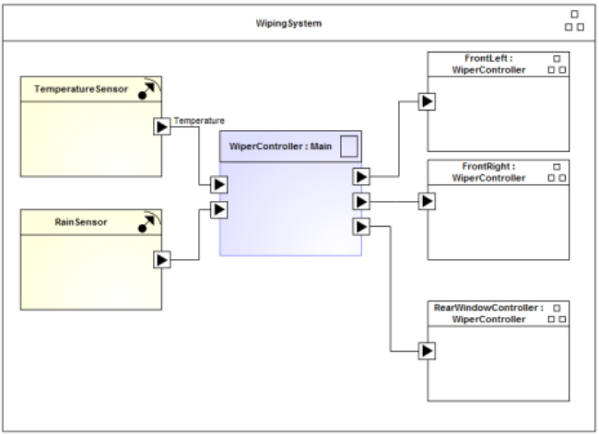

Figure 12: AUTOSAR compliant SW Component Architecture

### Function Deployment

***#Hint:*** *This section lists and details the deployment variants of the Feature.*

#### Deployment Variants

**#Classification:** Mandatory – State “No Variants defined”, if not used.

**#Hint:** If there is more than 1 variant of deployment, the different variant should be listed and described below. Deployment variants are very much driven by E/E architecture variants (refer to section E/E Architecture Variants). Nevertheless, Feature/Function variant options might also drive additional deployment variants.

|  |  |  |
| --- | --- | --- |
| **Deployment Variant Name** | Variant Description | Variant Condition (optional) |
|  |  |  |
|  |  |  |
|  |  |  |
|  |  |  |
|  |  |  |

##### Deployment “Variant 1”

***#Classification:*** *Optional*

***#Hint:*** *Add a deployment diagram (e.g. a SysML Activity Diagram where the actions represent the Logical Functions and the swimlanes represent the components) and some explanatory text about the variant to this section.*

This deployment variant … <add some explanatory text here>



Figure 7: Sample Deployment Diagram

#### Function Allocation

***#Hint:*** *The Function Allocation Table shows the mapping of the functions of the Feature* *to components of the physical architecture as also shown in the deployment diagrams.*

|  |  |  |
| --- | --- | --- |
| **Function ID** | **Function Name** | **Component Name** |
| F1 | Auto Tow Haul Arbitration and Processing | ECG |
| F2 | Powertrain Domain Arbitration | PCM, ECM |
| F3 | Chassis Domain Arbitration | ABS/SDM |
| F4 | AWD Domain Arbitration | TCCM, DLCM |
| F5 | Ignition Status Processing | BCM |
| F6 | Stabilizer Bar Status | CHCM |
| F7 | Display Processing | IPC |
| F8 | SDM Main Arbitration | ABS/SDM |
| F9 | HMI Domain Arbitration | ABS/SDM |

Table 19: Function Allocation Table

##### Functional Safety

| Component / Interface | Overall Component ASIL | Req IDs | Req ASIL | Function | Req IDs | Req ASIL |
| --- | --- | --- | --- | --- | --- | --- |
| Component 1 | C(D) | Req a | B | Function 1 | Req d |  |
| Req b | QM |  | Req e | B(C) |
| Req c | C(C) | Function 3 | Req f | C(D) |
|  |  | Function 4 | Req g | B(D) |
| Component 2 | B(C) | Req b | QM | Function 1 | Req d |  |
| Req h | B(C) |  |  |  |

Table 20: Function Allocation Table

|  |  |  |  |  |
| --- | --- | --- | --- | --- |
| **Affected Components/**  **Subsystems/ Data** | **Redundant Component/ Subsystem/ Data** | **If redundancy is used:** | | |
| **Rational for why the redundant component is needed/ suitable** | **Reference to Safety Analysis** | **Requirements Calling for redundancy (Reference to Req IDs)** |
|  |  |  |  |  |
|  |  |  |  |  |
|  |  |  |  |  |
|  |  |  |  |  |

Table 21: Architectural Redundancy Summary

## Feature Implementation Modeling

### Component Interaction Diagrams

#### Scenario: “System Startup / Shutdown”

#### Scenario: “Normal Operation”



Figure 13: Sequence Chart "Normal Operation"

#### Functional Safety

| **Component/ Subsystem** [or Communication Channel] | **F-S-Req-ID** | **Fault Handling Time (FHT)** | **Component Portion of the FHT**  [or Time Delay of Communication Channel] | **T-S-Req-ID** |
| --- | --- | --- | --- | --- |
| Component A | Functional Safety Requirement X |  |  |  |
|  |  |
|  |  |
|  |  |
|  |  |
|  |  |
| Component B | Functional Safety Requirement Y |  |  |  |
|  |  |
|  |  |

Table 22: Fault Handling Time Table

##### Requirements Derivation Diagram

### Component Interface Behavior Diagrams

### Requirements

#### Requirements on Components

##### **ECG**

###### Implemented Function: <F1> ATH Mode Arbitration and Processing

Function Interface

Inputs

|  |  |  |  |  |
| --- | --- | --- | --- | --- |
| **Logical Signal Name** | **Technical Signal Name** | **Mapping Details** *(Conditional)* | **Subscriber Interface** | **E/E Connection**  (*Optional)* |
| Name should be a Word reference to the *“Logical Signals”* name bookmark in the Data Dictionary | Name should be Word reference to the “*Technical Signals*”name bookmark in the *Data Dictionary* or a direct link e.g. to the GSDB signal in VSEM | If mapping is not 1:1 you might reference a Mapping description object from the *Mappings* section | Word reference to the “*Technical Interfaces*” name bookmark in the Data Dictionary (e.g. *AIS Interfaces* for CAN signals). | * Connection Name should be a reference to a Connection as given in the section *E/E Connections*. * For network connections add the message name to the connection name (Naming convention: <MessageName>::<ConnectionName>). The message name should be linked via a Word reference to the a “*Messages”* name bookmark in the Data Dictionary or for CAN signals to the VSEM CMDB (refer e.g. to[*CGEA 1.3*](https://www.vsemweb.ford.com/tc/launchapp?-attach=true&-s=226TCSession&-o=n0SJN9h0x3NrTDAAAAAAAAAAAAA&servername=Production_Server)or [*FNV2*](https://www.vsemweb.ford.com/tc/launchapp?-attach=true&-s=226TCSession&-o=jXfpx2PHx3NrTDAAAAAAAAAAAAA&servername=Production_Server)). |
|  | AutoTowAllw_D_RqMnu |  |  |  |
|  | AutoTowAllw_D_StatMnu |  |  |  |
|  | AutoTowActv_B_Stat |  |  |  |
|  | ActvDrvMde_D2_Stat |  |  |  |
|  | TrlrBrkActCnnct_B_Actl (TRM) or  TrlrLampCnnct_B_Actl (TTLM) |  |  |  |
|  | ActvDrvMde_D2_Stat |  |  |  |
|  |  |  |  |  |

Table 23: Input Signal mappings of Function “MyLogicalFunctionA_Component1”

Outputs

|  |  |  |  |  |
| --- | --- | --- | --- | --- |
| **Logical Signal Name** | **Technical Signal Name** | **Mapping Details**  *(Conditional)* | **Publisher Interface** | **E/E Connection**  *(Optional)* |
| Name should be a Word reference to the *“Logical Signals”* name bookmark in the Data Dictionary | Name should be Word reference to the “*Technical Signals*”name bookmark in the *Data Dictionary* or a direct link e.g. to the GSDB signal in VSEM | If mapping is not 1:1 you might reference a Mapping description object from the *Mappings* section | Word reference to the “*Technical Interfaces*” name bookmark in the Data Dictionary (e.g. *AIS Interfaces* for CAN signals). | * Connection Name should be a reference to a Connection as given in the section *E/E Connections*. * For network connections add the message name to the connection name (Naming convention: <MessageName>::<ConnectionName>). The message name should be linked via a Word reference to the a “*Messages”* name bookmark in the Data Dictionary or for CAN signals to the VSEM CMDB (refer e.g. to[*CGEA 1.3*](https://www.vsemweb.ford.com/tc/launchapp?-attach=true&-s=226TCSession&-o=n0SJN9h0x3NrTDAAAAAAAAAAAAA&servername=Production_Server)or [*FNV2*](https://www.vsemweb.ford.com/tc/launchapp?-attach=true&-s=226TCSession&-o=jXfpx2PHx3NrTDAAAAAAAAAAAAA&servername=Production_Server)). |
|  | AutoTowAllw_D_RqMnu | 1:1 |  |  |
|  | TrlrBrkActCnnct_B_Actl (TRM) | 1:1 |  |  |
|  | SelDrvMdePt_D_Stat | 1:1 |  |  |
|  | TrlrLampCnnct_B_Actl (TTLM | 1:1 |  |  |
|  |  |  |  |  |

Table 24: Output Signal mappings of Function “MyLogicalFunctionA_Component1”A

Parameters

|  |  |  |  |  |
| --- | --- | --- | --- | --- |
| **Logical Parameter Name** | **Technical Parameter Name** | **Mapping Details** *(Conditional)* | **Method** | **Method Details** |
| Name should be a Word reference to the “*Logical Parameters*” name bookmark in the Data Dictionary | Name should be a Word reference to the “*Technical Parameters*” name bookmark in the Data Dictionary | If mapping is not 1:1 you might reference a Mapping description object from the *Mappings* section | Choose an item. | Depends on Method selection. For Method 2 a DID including start bit and length could be given. For Central Car Config a signal could be referenced |
|  |  |  |  |  |
|  |  |  |  |  |
|  |  |  |  |  |
|  |  |  |  |  |

Table 25: Parameter mappings of Function “MyLogicalFunctionA_Component1”

Interface Requirements

Function Requirements

The ECG is allocated all requirements for function <F1> ATH Arbitration and Processing in section 4.1 of the functional specification

|  |  |  |
| --- | --- | --- |
| **Requirement ID**  (of Logical Function) | **Requirement Title** | **Comment** |
|  |  |  |
|  |  |  |
| … |  |  |

Table 27: Requirements Inherited from Logical Function

Component Specific Requirements

##### **PCM/ ECM**

###### Implemented Function: <F2> Powertrain Domain Arbitration

Function Interface

Inputs

|  |  |  |  |  |
| --- | --- | --- | --- | --- |
| **Logical Signal Name** | **Technical Signal Name** | **Mapping Details** *(Conditional)* | **Subscriber Interface** | **E/E Connection**  (*Optional)* |
| Name should be a Word reference to the *“Logical Signals”* name bookmark in the Data Dictionary | Name should be Word reference to the “*Technical Signals*”name bookmark in the *Data Dictionary* or a direct link e.g. to the GSDB signal in VSEM | If mapping is not 1:1 you might reference a Mapping description object from the *Mappings* section | Word reference to the “*Technical Interfaces*” name bookmark in the Data Dictionary (e.g. *AIS Interfaces* for CAN signals). | * Connection Name should be a reference to a Connection as given in the section *E/E Connections*. * For network connections add the message name to the connection name (Naming convention: <MessageName>::<ConnectionName>). The message name should be linked via a Word reference to the a “*Messages”* name bookmark in the Data Dictionary or for CAN signals to the VSEM CMDB (refer e.g. to[*CGEA 1.3*](https://www.vsemweb.ford.com/tc/launchapp?-attach=true&-s=226TCSession&-o=n0SJN9h0x3NrTDAAAAAAAAAAAAA&servername=Production_Server)or [*FNV2*](https://www.vsemweb.ford.com/tc/launchapp?-attach=true&-s=226TCSession&-o=jXfpx2PHx3NrTDAAAAAAAAAAAAA&servername=Production_Server)). |
|  | SelDrvMdePt_D_Rq |  |  |  |
|  | TrlrBrkActCnnct_B_Actl (TRM) |  |  |  |
|  | TrlrLampCnnct_B_Actl (TTLM |  |  |  |

Outputs

|  |  |  |  |  |
| --- | --- | --- | --- | --- |
| **Logical Signal Name** | **Technical Signal Name** | **Mapping Details**  *(Conditional)* | **Publisher Interface** | **E/E Connection**  *(Optional)* |
| Name should be a Word reference to the *“Logical Signals”* name bookmark in the Data Dictionary | Name should be Word reference to the “*Technical Signals*”name bookmark in the *Data Dictionary* or a direct link e.g. to the GSDB signal in VSEM | If mapping is not 1:1 you might reference a Mapping description object from the *Mappings* section | Word reference to the “*Technical Interfaces*” name bookmark in the Data Dictionary (e.g. *AIS Interfaces* for CAN signals). | * Connection Name should be a reference to a Connection as given in the section *E/E Connections*. * For network connections add the message name to the connection name (Naming convention: <MessageName>::<ConnectionName>). The message name should be linked via a Word reference to the a “*Messages”* name bookmark in the Data Dictionary or for CAN signals to the VSEM CMDB (refer e.g. to[*CGEA 1.3*](https://www.vsemweb.ford.com/tc/launchapp?-attach=true&-s=226TCSession&-o=n0SJN9h0x3NrTDAAAAAAAAAAAAA&servername=Production_Server)or [*FNV2*](https://www.vsemweb.ford.com/tc/launchapp?-attach=true&-s=226TCSession&-o=jXfpx2PHx3NrTDAAAAAAAAAAAAA&servername=Production_Server)). |
|  | SelDrvMdePt_D_Stat |  |  |  |
|  | AutoTowActv_B_Stat |  |  |  |
|  | AutoTowAllw_D_RqMnu |  |  |  |
|  | AutoTowActv_B_Stat |  |  |  |
|  |  |  |  |  |

Interface Requirements

Function Requirements

The PCM/ ECM is allocated all requirements for function <F2> Powertrain Domain Arbitration in section 4.2 of the functional specification

|  |  |  |  |  |
| --- | --- | --- | --- | --- |
| **Requirement ID**  (of Logical Function) | **Requirement Title** | **Modification** | **Requirement ID**  (of Implemented Function) | **Comment** |
| REQ_abc |  | Removed | -- |  |
| REQ_def |  | Replaced | REQ_xyz |  |
| -- |  | Added | REQ_123 |  |

|  |  |  |
| --- | --- | --- |
| **Requirement ID**  (of Logical Function) | **Requirement Title** | **Comment** |
|  |  |  |
|  |  |  |
| … |  |  |

Component Specific Requirements

##### **ABS/SDM**

###### Implemented Function: <F3> Chassis Domain Arbitration & <F5> SDM Main Arbitration

Function Interface

Inputs

|  |  |  |  |  |
| --- | --- | --- | --- | --- |
| **Logical Signal Name** | **Technical Signal Name** | **Mapping Details** *(Conditional)* | **Subscriber Interface** | **E/E Connection**  (*Optional)* |
| Name should be a Word reference to the *“Logical Signals”* name bookmark in the Data Dictionary | Name should be Word reference to the “*Technical Signals*”name bookmark in the *Data Dictionary* or a direct link e.g. to the GSDB signal in VSEM | If mapping is not 1:1 you might reference a Mapping description object from the *Mappings* section | Word reference to the “*Technical Interfaces*” name bookmark in the Data Dictionary (e.g. *AIS Interfaces* for CAN signals). | * Connection Name should be a reference to a Connection as given in the section *E/E Connections*. * For network connections add the message name to the connection name (Naming convention: <MessageName>::<ConnectionName>). The message name should be linked via a Word reference to the a “*Messages”* name bookmark in the Data Dictionary or for CAN signals to the VSEM CMDB (refer e.g. to[*CGEA 1.3*](https://www.vsemweb.ford.com/tc/launchapp?-attach=true&-s=226TCSession&-o=n0SJN9h0x3NrTDAAAAAAAAAAAAA&servername=Production_Server)or [*FNV2*](https://www.vsemweb.ford.com/tc/launchapp?-attach=true&-s=226TCSession&-o=jXfpx2PHx3NrTDAAAAAAAAAAAAA&servername=Production_Server)). |
|  | SelDrvMdePt_D_Stat |  |  |  |
|  | AutoTowActv_B_Stat |  |  |  |
|  | SelDrvMde_D_Stat |  |  |  |
|  |  |  |  |  |

Outputs

|  |  |  |  |  |
| --- | --- | --- | --- | --- |
| **Logical Signal Name** | **Technical Signal Name** | **Mapping Details**  *(Conditional)* | **Publisher Interface** | **E/E Connection**  *(Optional)* |
| Name should be a Word reference to the *“Logical Signals”* name bookmark in the Data Dictionary | Name should be Word reference to the “*Technical Signals*”name bookmark in the *Data Dictionary* or a direct link e.g. to the GSDB signal in VSEM | If mapping is not 1:1 you might reference a Mapping description object from the *Mappings* section | Word reference to the “*Technical Interfaces*” name bookmark in the Data Dictionary (e.g. *AIS Interfaces* for CAN signals). | * Connection Name should be a reference to a Connection as given in the section *E/E Connections*. * For network connections add the message name to the connection name (Naming convention: <MessageName>::<ConnectionName>). The message name should be linked via a Word reference to the a “*Messages”* name bookmark in the Data Dictionary or for CAN signals to the VSEM CMDB (refer e.g. to[*CGEA 1.3*](https://www.vsemweb.ford.com/tc/launchapp?-attach=true&-s=226TCSession&-o=n0SJN9h0x3NrTDAAAAAAAAAAAAA&servername=Production_Server)or [*FNV2*](https://www.vsemweb.ford.com/tc/launchapp?-attach=true&-s=226TCSession&-o=jXfpx2PHx3NrTDAAAAAAAAAAAAA&servername=Production_Server)). |
|  | SelDrvMdeChassis2_D_Rq |  |  |  |
|  | SelDrvMdeChassis_D_Rq |  |  |  |
|  | SelDrvMdeAWD_D_Rq |  |  |  |
|  | ActvDrvMde_D2_Stat |  |  |  |
|  |  |  |  |  |
|  |  |  |  |  |

Interface Requirements

Function Requirements

The ABS/SDM is allocated all requirements for function <F3> Chassis Domain Arbitration in section 4.3 and function <F5> SDM Main Arbitration of section 4.5 of the functional specification

|  |  |  |  |  |
| --- | --- | --- | --- | --- |
| **Requirement ID**  (of Logical Function) | **Requirement Title** | **Modification** | **Requirement ID**  (of Implemented Function) | **Comment** |
| REQ_abc |  | Removed | -- |  |
| REQ_def |  | Replaced | REQ_xyz |  |
| -- |  | Added | REQ_123 |  |

Component Specific Requirements

##### **TCCM**

###### Implemented Function: <F4> Driveline Domain Arbitration

Function Interface

Inputs

|  |  |  |  |  |
| --- | --- | --- | --- | --- |
| **Logical Signal Name** | **Technical Signal Name** | **Mapping Details** *(Conditional)* | **Subscriber Interface** | **E/E Connection**  (*Optional)* |
| Name should be a Word reference to the *“Logical Signals”* name bookmark in the Data Dictionary | Name should be Word reference to the “*Technical Signals*”name bookmark in the *Data Dictionary* or a direct link e.g. to the GSDB signal in VSEM | If mapping is not 1:1 you might reference a Mapping description object from the *Mappings* section | Word reference to the “*Technical Interfaces*” name bookmark in the Data Dictionary (e.g. *AIS Interfaces* for CAN signals). | * Connection Name should be a reference to a Connection as given in the section *E/E Connections*. * For network connections add the message name to the connection name (Naming convention: <MessageName>::<ConnectionName>). The message name should be linked via a Word reference to the a “*Messages”* name bookmark in the Data Dictionary or for CAN signals to the VSEM CMDB (refer e.g. to[*CGEA 1.3*](https://www.vsemweb.ford.com/tc/launchapp?-attach=true&-s=226TCSession&-o=n0SJN9h0x3NrTDAAAAAAAAAAAAA&servername=Production_Server)or [*FNV2*](https://www.vsemweb.ford.com/tc/launchapp?-attach=true&-s=226TCSession&-o=jXfpx2PHx3NrTDAAAAAAAAAAAAA&servername=Production_Server)). |
|  | SelDrvMdeAwd_D_Rq | 1:1 |  |  |
|  |  |  |  |  |

Outputs

|  |  |  |  |  |
| --- | --- | --- | --- | --- |
| **Logical Signal Name** | **Technical Signal Name** | **Mapping Details**  *(Conditional)* | **Publisher Interface** | **E/E Connection**  *(Optional)* |
| Name should be a Word reference to the *“Logical Signals”* name bookmark in the Data Dictionary | Name should be Word reference to the “*Technical Signals*”name bookmark in the *Data Dictionary* or a direct link e.g. to the GSDB signal in VSEM | If mapping is not 1:1 you might reference a Mapping description object from the *Mappings* section | Word reference to the “*Technical Interfaces*” name bookmark in the Data Dictionary (e.g. *AIS Interfaces* for CAN signals). | * Connection Name should be a reference to a Connection as given in the section *E/E Connections*. * For network connections add the message name to the connection name (Naming convention: <MessageName>::<ConnectionName>). The message name should be linked via a Word reference to the a “*Messages”* name bookmark in the Data Dictionary or for CAN signals to the VSEM CMDB (refer e.g. to[*CGEA 1.3*](https://www.vsemweb.ford.com/tc/launchapp?-attach=true&-s=226TCSession&-o=n0SJN9h0x3NrTDAAAAAAAAAAAAA&servername=Production_Server)or [*FNV2*](https://www.vsemweb.ford.com/tc/launchapp?-attach=true&-s=226TCSession&-o=jXfpx2PHx3NrTDAAAAAAAAAAAAA&servername=Production_Server)). |
|  | SelDrvMdeAwd2_D_Stat | 1:1 |  |  |
|  |  |  |  |  |

Interface Requirements

Function Requirements

The TCCM is allocated all requirements for function <F4> Driveline Domain Arbitration in section 4.4 of the functional specification

|  |  |  |  |  |
| --- | --- | --- | --- | --- |
| **Requirement ID**  (of Logical Function) | **Requirement Title** | **Modification** | **Requirement ID**  (of Implemented Function) | **Comment** |
| REQ_abc |  | Removed | -- |  |
| REQ_def |  | Replaced | REQ_xyz |  |
| -- |  | Added | REQ_123 |  |

Component Specific Requirements

##### **EPAS**

###### Implemented Function: <F3> Chassis Domain Arbitration Function

Function Interface

Inputs

|  |  |  |  |  |
| --- | --- | --- | --- | --- |
| **Logical Signal Name** | **Technical Signal Name** | **Mapping Details** *(Conditional)* | **Subscriber Interface** | **E/E Connection**  (*Optional)* |
| Name should be a Word reference to the *“Logical Signals”* name bookmark in the Data Dictionary | Name should be Word reference to the “*Technical Signals*”name bookmark in the *Data Dictionary* or a direct link e.g. to the GSDB signal in VSEM | If mapping is not 1:1 you might reference a Mapping description object from the *Mappings* section | Word reference to the “*Technical Interfaces*” name bookmark in the Data Dictionary (e.g. *AIS Interfaces* for CAN signals). | * Connection Name should be a reference to a Connection as given in the section *E/E Connections*. * For network connections add the message name to the connection name (Naming convention: <MessageName>::<ConnectionName>). The message name should be linked via a Word reference to the a “*Messages”* name bookmark in the Data Dictionary or for CAN signals to the VSEM CMDB (refer e.g. to[*CGEA 1.3*](https://www.vsemweb.ford.com/tc/launchapp?-attach=true&-s=226TCSession&-o=n0SJN9h0x3NrTDAAAAAAAAAAAAA&servername=Production_Server)or [*FNV2*](https://www.vsemweb.ford.com/tc/launchapp?-attach=true&-s=226TCSession&-o=jXfpx2PHx3NrTDAAAAAAAAAAAAA&servername=Production_Server)). |
|  | SelDrvMdeChassis2_D_Rq | 1:1 |  |  |
|  |  |  |  |  |

Outputs

|  |  |  |  |  |
| --- | --- | --- | --- | --- |
| **Logical Signal Name** | **Technical Signal Name** | **Mapping Details**  *(Conditional)* | **Publisher Interface** | **E/E Connection**  *(Optional)* |
| Name should be a Word reference to the *“Logical Signals”* name bookmark in the Data Dictionary | Name should be Word reference to the “*Technical Signals*”name bookmark in the *Data Dictionary* or a direct link e.g. to the GSDB signal in VSEM | If mapping is not 1:1 you might reference a Mapping description object from the *Mappings* section | Word reference to the “*Technical Interfaces*” name bookmark in the Data Dictionary (e.g. *AIS Interfaces* for CAN signals). | * Connection Name should be a reference to a Connection as given in the section *E/E Connections*. * For network connections add the message name to the connection name (Naming convention: <MessageName>::<ConnectionName>). The message name should be linked via a Word reference to the a “*Messages”* name bookmark in the Data Dictionary or for CAN signals to the VSEM CMDB (refer e.g. to[*CGEA 1.3*](https://www.vsemweb.ford.com/tc/launchapp?-attach=true&-s=226TCSession&-o=n0SJN9h0x3NrTDAAAAAAAAAAAAA&servername=Production_Server)or [*FNV2*](https://www.vsemweb.ford.com/tc/launchapp?-attach=true&-s=226TCSession&-o=jXfpx2PHx3NrTDAAAAAAAAAAAAA&servername=Production_Server)). |
|  | SelDrvMdeSte_D_Stat | 1:1 |  |  |
|  |  |  |  |  |

Interface Requirements

Function Requirements

The EPAS is allocated all requirements for function <F3> Chassis Domain Arbitration Function in section 4.3 of the functional specification

|  |  |  |  |  |
| --- | --- | --- | --- | --- |
| **Requirement ID**  (of Logical Function) | **Requirement Title** | **Modification** | **Requirement ID**  (of Implemented Function) | **Comment** |
| REQ_abc |  | Removed | -- |  |
| REQ_def |  | Replaced | REQ_xyz |  |
| -- |  | Added | REQ_123 |  |

##### **VDM/SUMA**

###### Implemented Function: <F3> Chassis Domain Arbitration Function

Function Interface

Inputs

|  |  |  |  |  |
| --- | --- | --- | --- | --- |
| **Logical Signal Name** | **Technical Signal Name** | **Mapping Details** *(Conditional)* | **Subscriber Interface** | **E/E Connection**  (*Optional)* |
| Name should be a Word reference to the *“Logical Signals”* name bookmark in the Data Dictionary | Name should be Word reference to the “*Technical Signals*”name bookmark in the *Data Dictionary* or a direct link e.g. to the GSDB signal in VSEM | If mapping is not 1:1 you might reference a Mapping description object from the *Mappings* section | Word reference to the “*Technical Interfaces*” name bookmark in the Data Dictionary (e.g. *AIS Interfaces* for CAN signals). | * Connection Name should be a reference to a Connection as given in the section *E/E Connections*. * For network connections add the message name to the connection name (Naming convention: <MessageName>::<ConnectionName>). The message name should be linked via a Word reference to the a “*Messages”* name bookmark in the Data Dictionary or for CAN signals to the VSEM CMDB (refer e.g. to[*CGEA 1.3*](https://www.vsemweb.ford.com/tc/launchapp?-attach=true&-s=226TCSession&-o=n0SJN9h0x3NrTDAAAAAAAAAAAAA&servername=Production_Server)or [*FNV2*](https://www.vsemweb.ford.com/tc/launchapp?-attach=true&-s=226TCSession&-o=jXfpx2PHx3NrTDAAAAAAAAAAAAA&servername=Production_Server)). |
|  | SelDrvMdeChassis_D_Rq | 1:1 |  |  |
|  |  |  |  |  |

Outputs

|  |  |  |  |  |
| --- | --- | --- | --- | --- |
| **Logical Signal Name** | **Technical Signal Name** | **Mapping Details**  *(Conditional)* | **Publisher Interface** | **E/E Connection**  *(Optional)* |
| Name should be a Word reference to the *“Logical Signals”* name bookmark in the Data Dictionary | Name should be Word reference to the “*Technical Signals*”name bookmark in the *Data Dictionary* or a direct link e.g. to the GSDB signal in VSEM | If mapping is not 1:1 you might reference a Mapping description object from the *Mappings* section | Word reference to the “*Technical Interfaces*” name bookmark in the Data Dictionary (e.g. *AIS Interfaces* for CAN signals). | * Connection Name should be a reference to a Connection as given in the section *E/E Connections*. * For network connections add the message name to the connection name (Naming convention: <MessageName>::<ConnectionName>). The message name should be linked via a Word reference to the a “*Messages”* name bookmark in the Data Dictionary or for CAN signals to the VSEM CMDB (refer e.g. to[*CGEA 1.3*](https://www.vsemweb.ford.com/tc/launchapp?-attach=true&-s=226TCSession&-o=n0SJN9h0x3NrTDAAAAAAAAAAAAA&servername=Production_Server)or [*FNV2*](https://www.vsemweb.ford.com/tc/launchapp?-attach=true&-s=226TCSession&-o=jXfpx2PHx3NrTDAAAAAAAAAAAAA&servername=Production_Server)). |
|  | SelDrvMdeAirSusp_D_Stat |  |  |  |
|  | SelDrvMdeSte_D_Stat |  |  |  |
|  | SelDrvMdeSusp_D_Stat |  |  |  |
|  |  |  |  |  |

Interface Requirements

Function Requirements

The VDM/SUMA is allocated all requirements for function <F3> Chassis Domain Arbitration function in section 4.3 of the functional specification

|  |  |  |  |  |
| --- | --- | --- | --- | --- |
| **Requirement ID**  (of Logical Function) | **Requirement Title** | **Modification** | **Requirement ID**  (of Implemented Function) | **Comment** |
| REQ_abc |  | Removed | -- |  |
| REQ_def |  | Replaced | REQ_xyz |  |
| -- |  | Added | REQ_123 |  |

##### **ITRM**

###### Implemented Function: <F2> Powertrain Domain Arbitration Function

Function Interface

Inputs

|  |  |  |  |  |
| --- | --- | --- | --- | --- |
| **Logical Signal Name** | **Technical Signal Name** | **Mapping Details** *(Conditional)* | **Subscriber Interface** | **E/E Connection**  (*Optional)* |
| Name should be a Word reference to the *“Logical Signals”* name bookmark in the Data Dictionary | Name should be Word reference to the “*Technical Signals*”name bookmark in the *Data Dictionary* or a direct link e.g. to the GSDB signal in VSEM | If mapping is not 1:1 you might reference a Mapping description object from the *Mappings* section | Word reference to the “*Technical Interfaces*” name bookmark in the Data Dictionary (e.g. *AIS Interfaces* for CAN signals). | * Connection Name should be a reference to a Connection as given in the section *E/E Connections*. * For network connections add the message name to the connection name (Naming convention: <MessageName>::<ConnectionName>). The message name should be linked via a Word reference to the a “*Messages”* name bookmark in the Data Dictionary or for CAN signals to the VSEM CMDB (refer e.g. to[*CGEA 1.3*](https://www.vsemweb.ford.com/tc/launchapp?-attach=true&-s=226TCSession&-o=n0SJN9h0x3NrTDAAAAAAAAAAAAA&servername=Production_Server)or [*FNV2*](https://www.vsemweb.ford.com/tc/launchapp?-attach=true&-s=226TCSession&-o=jXfpx2PHx3NrTDAAAAAAAAAAAAA&servername=Production_Server)). |
|  | TrlrBrkActCnnct_B_Actl (TRM) or  TrlrLampCnnct_B_Actl (TTLM) | 1:1 |  |  |
|  |  |  |  |  |

Outputs

|  |  |  |  |  |
| --- | --- | --- | --- | --- |
| **Logical Signal Name** | **Technical Signal Name** | **Mapping Details**  *(Conditional)* | **Publisher Interface** | **E/E Connection**  *(Optional)* |
| Name should be a Word reference to the *“Logical Signals”* name bookmark in the Data Dictionary | Name should be Word reference to the “*Technical Signals*”name bookmark in the *Data Dictionary* or a direct link e.g. to the GSDB signal in VSEM | If mapping is not 1:1 you might reference a Mapping description object from the *Mappings* section | Word reference to the “*Technical Interfaces*” name bookmark in the Data Dictionary (e.g. *AIS Interfaces* for CAN signals). | * Connection Name should be a reference to a Connection as given in the section *E/E Connections*. * For network connections add the message name to the connection name (Naming convention: <MessageName>::<ConnectionName>). The message name should be linked via a Word reference to the a “*Messages”* name bookmark in the Data Dictionary or for CAN signals to the VSEM CMDB (refer e.g. to[*CGEA 1.3*](https://www.vsemweb.ford.com/tc/launchapp?-attach=true&-s=226TCSession&-o=n0SJN9h0x3NrTDAAAAAAAAAAAAA&servername=Production_Server)or [*FNV2*](https://www.vsemweb.ford.com/tc/launchapp?-attach=true&-s=226TCSession&-o=jXfpx2PHx3NrTDAAAAAAAAAAAAA&servername=Production_Server)). |
|  | TrlrBrkActCnnct_B_Actl (TRM) or  TrlrLampCnnct_B_Actl (TTLM) | 1:1 |  |  |
|  |  |  |  |  |

Interface Requirements

Function Requirements

The ITRM is allocated all requirements for function <F2> Powertrain Domain Arbitration function in section 4.2 of the functional specification.

|  |  |  |  |  |
| --- | --- | --- | --- | --- |
| **Requirement ID**  (of Logical Function) | **Requirement Title** | **Modification** | **Requirement ID**  (of Implemented Function) | **Comment** |
| REQ_abc |  | Removed | -- |  |
| REQ_def |  | Replaced | REQ_xyz |  |
| -- |  | Added | REQ_123 |  |

#### Requirements on Connections

##### CAN Bus x

###### Protocol Requirements

Message List

###### Electrical Requirements

##### MS-CAN

##### LIN x

###### Protocol Requirements

Message List

Schedule Table

###### Electrical Requirements

##### Ethernet

##### WLAN (IEEE 802.11.x)

##### RF

##### Hardwired I/Os

#### Requirements on Development Process

# OPEN CONCERNS

**#Hint:** The following list presents open concerns, which have to be discussed or clarified over the course of the on-going requirements engineering.

| ID | Concern Description | e-Tracker / Reference | Responsible | Status | Solution |
| --- | --- | --- | --- | --- | --- |
| 1 |  |  |  |  |  |
| 2 |  |  |  |  |  |
| 3 |  |  |  |  |  |
| 4 |  |  |  |  |  |
| 5 |  |  |  |  |  |
| 6 |  |  |  |  |  |
| 7 |  |  |  |  |  |
| 8 |  |  |  |  |  |
| 9 |  |  |  |  |  |

Table 28: Open Concerns

# REVISION HISTORY

|  |  |  |  |  |  |
| --- | --- | --- | --- | --- | --- |
| Rev.  (revision) | Vers. | Date | Description | Approved by | Responsible |
| *001* |  |  |  |  |  |

## Template Revisions

*#Important: Do not change this section*

|  |  |  |  |  |
| --- | --- | --- | --- | --- |
| Version | Rev. | Date | Description | Responsible |
| *1* | *0* | *2016-04-07* | * *Initial version based on FDS v1.2 and Feature Doc 1.5 structure* | *Jbaden1* |
| *1* | *1* | *2016-05-10* | * *Minor rewording in ch. 1.1* * *Cleanup of document properties* | *Jbaden1* |
| *1* | *2* | *2016-06-16* | * *Lessons learned from pilots incorporated into feature and function decomposition part.* | *Jbaden1* |
| *1* | *3* | *2016-07-08* | * *Template version added to footer.* | *Jbaden1* |
| *2* | *0* | *2016-07-15* | * *Template updated according to latest Feature, Function and Platform Specification Templates* * *RE_SafetyRequirement style added* | *Jbaden1* |
| *3* | *0* | *2016-09-05* | * *Lessons learned from IPRB pilot incorporated* * *Harmonization with CV&S PRD* | *Jbaden1* |
| *3* | *1* | *2016-12-09* | * *Logical Signal and Data Types section content moved to Specification_Macros.dotm (v3.1)* | *Jbaden1* |
| *4* |  |  | *Skipped to synchronize with Specification_Macros.dotm* |  |
| *5* | *0* | *2017-01-13* | * *Meta data updated for specification macros, version 3.1* * *SW Unit chapter removed for the time being* * *Green boxes added for user hints* | *Jbaden1* |
| *5* | *1b* | *2017-01-31* | * *Some editorial corrections* * *Substructure of old Network Communication (now Connections) moved to Requirements on Connections* * *Harmonized with FIS template* | *Jbaden1* |
| *6* | *0* | *2017-04-28* | * *RequirementsTraceability chapter removed* | *Jbaden1* |
| *6* | *0* | *2018-07-18* | * *CR73: Expand ToC of AFS to level 5* * *CR63: Updated links to Functional Safety Sharepoint* * *CR74: new chapter “Safety Assumptions” added* * *CR75: Some rewording -> Terminology to Glossary, Notation -> Document Conventions* * *CR76: no longer maintain 2 different sections for configuration and for calibration parameters* | *Jbaden1* |
| *6* | *0* | *2018-08-06* | * *CR53: New non-FAP-150 cover sheet* * *CR80: Harmonize chapters of the Aggregated Feature Spec and the Aggregated Service Spec with the Function Group Spec. Each Function subsection should follow exactly the Function Spec Template* * *CR81: Incorporate lessons learned from System Service Spec pilot (Vehicle Speed) into AFS and FIS* | *Jbaden1* |
| *6* | *0* | *2018-09-28* | * *Broken links to RE Wiki repaired* | *Jbaden1* |
| *6* | *0* | *2018-10-31* | * *“Overview” and “Description” exchanged in headings* * *Some smaller modifications on cover sheet and in footer* * *Functinonal Safety alignment:*   + *New sections “Parameter / Values” on Feature level, Functional Safety Req. and (Decomposed) Functional Safety Req. added*   + *“Logical Architecture” Section removed* | *Jbaden1* |
| *6* | *0* | *2018-12-01* | * *Variant condition fields added consistently* * *Links updated* * *Background, Goals, Objectives, … removed. Left to separate document Feature Charter Document* | *Jbaden1* |
| *6* | *0a* | *2019-01-03* | * *Chapter heading “Inherited Function Requirements” removed. Corresponding table renamed to “Requirements not cascaded”.* * *E/E Connection table got another column for allocated messages* * *Naming conventions for Implemented Functions corrected (FncName_CmpName instead of FncName_on_CmpName)* * *Editorial corrections on the cover sheet* * *Explanatory text added to “Ethernet” section in chapter “Requirements on Connections”* * *AIS templates updated. Linked to Wiki page* | *Jbaden1* |
| *6* | *0b* | *2019-01-15* | * *Change: "doc acronym" and "product type" added to Word doc properties to ease spec alignment of certain capters across FIS, AFS and ASS.* * *Bugfix: table 22 renamed from FTTI table to FHT table, includes a bug fix: each FSR is allocated to only one ECU/component* | *Jbaden1* |
| *6* | *0b* | *2019-02-04* | * *Change: Chapter “Interface Requirements” added to “Implemented Function xxx” section (to have a single chapter for to collect subscriber/publisher interface and mapping requirements which to not conform to the corresponding Data Dictionary objects)* * *Change: “CAN Interface” subsection renamed to “AIS Interfaces” again. Although several Subscriber/Publisher interface attributes are probably CAN bus specific, other attributes seem to be well suited for other networks than CAN.* * *Change: Chapter “ECU Specific Requirements” renamed to “Component Specific Requirements” in chapter “Implemented Function xxx”. Table “Requirements not cascaded” renamed to “Component Specific Requirements” and refined to describe changes from Logical Function requirements set more formally. This is also to help during VSEM import to identify those requirements of the Logical Function which cannot be simply carried over to the ECU.* * *Change: Explanatory text in section “Implemented Function xxx” improved.* | *Jbaden1* |
| *6* | *0b* | *2019-02-05* | * *Change: Layout of AIS Interfaces in Data Dictionary reworked to enable Excel Import* | *Jbaden1* |
| *6* | *0c* | *2019-02-20* | * *Bugfix: AIS Interfaces tables partially formatted incorrectly (heading “Network Timing” and “Signal Integrity/Robustness” got exported for Publisher Interface). A few values formatted as invisible* | *Jbaden1* |

# APPENDIX

## Data Dictionary

### Logical Signals

### Logical Parameters

### Technical Signals

#### GSDB Signals

#### Service Oriented Communication

#### Hardwired Signals

#### Diagnostic Interfaces

##### DTCs

###<DTC_<ID>>### <DTC Name>

<Some Description of the DTC.

Refer to VSEM document “[Diagnostic Fault Coverage and DTC Numbers](https://www.vsemweb.ford.com/tc/launchapp?-attach=true&-s=226TCSession&-o=yAUtrNhnx3NrTDAAAAAAAAAAAAA&servername=Production_Server)

[Design Consideration](https://www.vsemweb.ford.com/tc/launchapp?-attach=true&-s=226TCSession&-o=yAUtrNhnx3NrTDAAAAAAAAAAAAA&servername=Production_Server)”, what to fill into the attributes below>

|  |  |
| --- | --- |
| **Test Period Time** |  |
| **Test Run Criteria,** |  |
| **Enable Criteria (EC)** |  |
| **Applicable** |  |
| **FailureTypeBytes** |  |
| **Test Period Time** |  |
| **Test Run Criteria,** |  |

##### DIDs

### Technical Parameters

### Mappings

###<MAP_MappingID>### <MAP_LogicalSignalName_TechnicalSignalName>

<Some Description of the Mapping>

|  |  |  |  |  |
| --- | --- | --- | --- | --- |
| **Logical Signal/Parameter** | | | **Technical Signal(s)/Parameter(s)** | |
| **Name** | | <Logical Signal Name> | **Name(s)** | <Technical Signal / Parameter Names> |
| **Encoding Type** | | <Name of Encoding Type> | **Mapping Details** | <Description how encoding of logical signal maps to the the one of the technical signal(s)/parameter(s)> |
| Note: An encoding is either discrete or continuous. Delete fields below which are not needed | | |
| **Value**  (continuous encoding) | Min Value |  |
| Max Value |  |
| Resolution |  |
| Offset |  |
| **Value**  (discrete encoding) | Value 1 | <Interpretation of value 1> |
| Value 2 | … |
| … | … |
|  |  |
|  |  |
| **Unit** | |  |

### Technical Interfaces

#### AIS Interfaces

##### Publisher Interfaces

|  |  |  |
| --- | --- | --- |
| Requirement ID: ###**PUBIF_AIS_InterfaceID**### | | |
| Interface Name | | **PubIf_TechnicalSignalName**  *(Please follow the naming convention “PubIf_TechnicalSignalName”. Optionally you may create a Word bookmark for the Interface Name. This allows referencing the Mapping object in the rest of the document)* | |
| Interface Description | | Some Description of the Publisher Interface of the Technical Signal | |
| **Signal Robustness/Integrity** | | | |
| Functional Safety Relevant | | Choose an item. | |
| Checksum | | Choose an item. | |
| Counter | | Choose an item. | |
| **Network Timing** | | | |
| Publishing Interval (ms) | |  | |
| Publisher Latency (ms) | |  | |
| Signal Transmit Strategy | | Choose an item. | |
| Signal Send Type | | Choose an item. | |
| Signal Refresh Rate (ms) | |  | |
| **Network Management** | | | |
| Publishing Network Sleep Inhibitor | |  | |
| Network Wake Up | | Choose an item. | |
| Signal Update While Network Asleep | | Choose an item. | |
| Fresh data on Network wakeup | | Choose an item. | |
| Max latency before signal is valid on Network wakeup(ms) | |  | |
| **Reset Behavior** | | | |
| Fresh data on ECU Reset | | Choose an item. | |
| Max latency before signal is valid on reset (ms) | |  | |
| **Functional Characteristics** | | | |
| ECU Power Mode | | Choose an item. | |
| CAN Node Type | | Choose an item. | |
| [Req. Template](http://wiki.ford.com/display/RequirementsEngineering/Requirements+Attributes) Version | 6.0c | End of Requirement | |

##### Subscriber Interfaces

|  |  |  |  |
| --- | --- | --- | --- |
| Requirement ID: ###**SUBIF_AIS_InterfaceID**### | | | |
| Interface Name | | **SubIf_TechnicalSignalName**  *(Please follow the naming convention “SubIf_TechnicalSignalName”. Optionally you may create a Word bookmark for the Interface Name. This allows referencing the Interface object in the rest of the document)* | |
| Interface Description | | Some Description of the Subscriber Interface of the Technical Signal | |
| **Signal Robustness/Integrity** | | | |
| Functional Safety Relevant | | Choose an item. | |
| Checksum | | Choose an item. | |
| Counter | | Choose an item. | |
| **Network Timing** | | | |
| Subscribing Interval (ms) | |  | |
| Subscriber Latency (ms) | |  | |
| **Network Management** | | | |
| Subscribing Network Sleep Inhibitor | |  | |
| Network Wake Up | | Choose an item. | |
| **Network Routing** | | | |
| Gateway Required | | Choose an item. | |
| Max Gateway Latency (ms) | |  | |
| Gateway Message Type | | Choose an item. | |
| **Missing Message Strategy** | | | |
| Missing Message Strategy | | Choose an item. | |
| Time Period for Last Signal Value to be used | |  | |
| Missing Message Default Value | |  | |
| Missing Message DTC | |  | |
| Missing Message Strategy Details | |  | |
| **Functional Characteristics** | | | |
| ECU Power Mode | | Choose an item. | |
| [Req. Template](http://wiki.ford.com/display/RequirementsEngineering/Requirements+Attributes) Version | 6.0c | | End of Requirement |

#### Service Oriented Communication (SoC) Interfaces

#### AUTOSAR Ports (SW Interfaces)

### Messages

#### CAN Bus “<Bus Name>”

#### LIN Bus “<Bus Name>”

### Encoding Types

### Document ends here